FAQ’s About the FHSU Massage Therapy Program

Are there any pre-requisites for the program?
No. General Education requirements are not necessary for the certificate program.
What is the process for admission into the program?
- Apply to FHSU online www.fhsu.edu 2. Transfer transcripts 3. Apply for FAFSA if you are seeking financial assistance.
What is the cost for the program?
Currently, 12/2022 the total cost for the ENTIRE program is roughly $7200 + books
Where are the hands-on classes held?
All hands-on classes are held on campus Memorial Union, rm 045 (Downstairs from Starbucks)
Is the FHSU Massage Therapy program accredited?
Yes, through the Kansas Board of Regents.
When may I start the program?
Currently as of 12/2022, students may start in the Summer or Fall semesters only.
How many hours/credits is the FHSU Massage program?
Our program is 32 credit hours, and 512 hands on hours. We are a hybrid format; half online and half in person.
How much can a massage therapist make in income?
Per Salary.com, the average massage therapist makes $43,101-$55,335 per year + tips/gratuity, 5/2022

What education options do I have with Massage Therapy?
Certificate in Massage Therapy, Associate in General Studies concentration Massage Therapy (example), Bachelor in Health Studies concentration in Massage Therapy

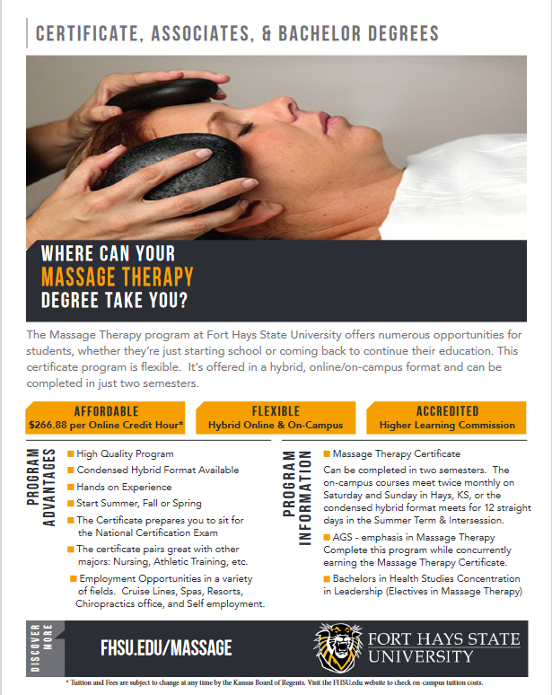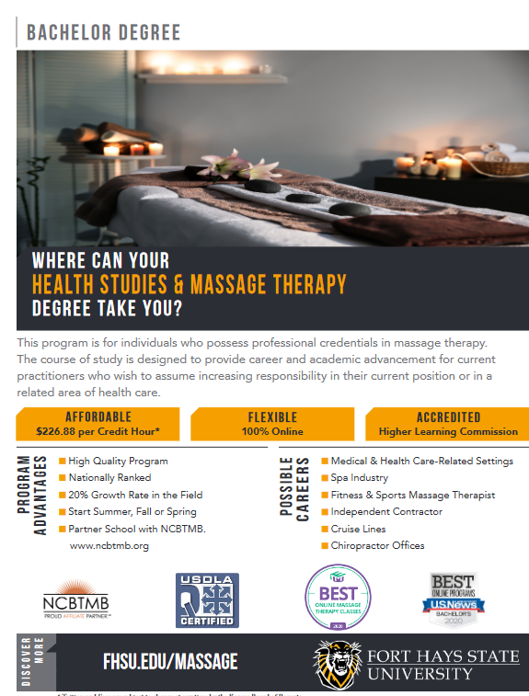

Is there job placement after graduation?
All graduates have access to a lifelong employment page that lists local/state/national job opportunities.
What type of modalities will I learn in school?
Students learn myofascial release, deep tissue, Swedish, Thai Stretching, Hot Stones, Chinese Cupping, Sports with the supplement of guest speakers on specialty modalities.
Do I need to buy any supplies for school?
The FHSU Massage program provides all linens, tables, lubricant, and tools for use while in the program. Information is given to students if they are wishing to buy outside of class. Clinic shirts and insurance is provided to students. Students are responsible for a background check, cost $49. Information will be given in class.
Where can a massage therapist work?
Massage Therapists may work for themselves as entrepreneurs or in other healthcare establishments such as: spas, health clubs, hospitals, cruise lines, tanning salons, chiropractors, veterinary clinics, etc.
~~ For specific admission questions, contact: https://www.fhsu.edu/admissions/
~~ For specific financial aid questions, contact: https://www.fhsu.edu/finaid/
~~ For more information, reach out to Ceena Lund, Director of Massage Therapy cmowens2@fhsu.edu 785-639-7218

