

Dear Tiger,

I am pleased to reach out to you from Fort Hays State University’s Robbins College of Business and Entrepreneurship (RCOBE). The fall semester has begun and the weather is cooling. Your Fort Hays State University campus looks great. I encourage you to visit (and bring your friends, children, grandchildren and anyone else who would enjoy visiting campus and learning more about a remarkable university).

**New Buildings**

Three new buildings have opened for the fall semester. These include the Center for Applied Technology & Sculpture (CATS), Victor E. Village, and Tiger Village. The new track and field complex has also opened. In Fort Hays State University fashion, these are state-of-the art facilities. As Dean of the Robbins College of Business and Entrepreneurship, I am excited about these additions. I believe that the Center for Applied Technology will be a boon to construction and manufacturing companies in Kansas. Its sculpture facility is one of the best in the nation. Faculty from both the Department of Applied Technology and the Department of Art and Design are interested in connecting their students to entrepreneurship education in our college. Victor E. Village and Tiger Village (you can reduce confusion by putting *your* name on one of these facilities!) will provide very nice student housing, replacing Weist Hall, and will provide much-improved Greek housing. These new residence halls will make it easier to recruit students to campus. Two RCOBE freshmen learning communities are living in Victor E. Village.

**Robbins Banking Institute**

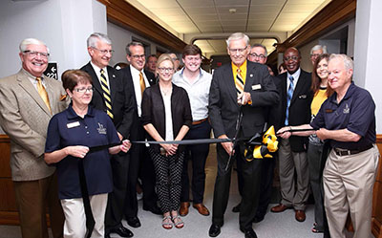

The Robbins College of Business and Entrepreneurship has had a major ribbon cutting of our own. On August 25, 2017 we celebrated the official opening of the new Robbins Banking Institute located within McCartney Hall. Fort Hays State now offers the most extensive banking curriculum in Kansas and is one of the few universities in the country to offer banking classes both on campus and through distance learning. The Robbins Banking Institute fills the void many banking representatives experience in finding qualified employees. The focus of the curriculum is on commercial banking with additional coursework available related to agricultural lending. The namesakes of the Robbins Banking Institute, W.R. Robbins, an FHSU alumnus, and his wife, Yvonne, are longtime, devoted supporters of the university. W.R. is the chair of Farmers Bank and Trust, Great Bend, which owns and manages seven locations in central Kansas and two in Johnson County. Alan Deines was named in June as the inaugural director of the Institute.  For more information, please follow these links;

<http://www.fhsu.edu/news/Fort-Hays-State-s-new-Robbins-Banking-Institute-now-officially-open-for-business/>

<http://www.fhsu.edu/news/New-banking-institute-at-Fort-Hays-State-names-Alan-Deines-as-its-first-director/>

**Scholarships Awarded to Students**

The Robbins College of Business and Entrepreneurship hosted its annual Awards Ceremony on Thursday, September 14, 2017 in the Fort Hays Ballroom of the Memorial Union. We awarded 212 ­­­scholarships to RCOBE majors totaling $164,532 and 36.5 full-time graduate tuition assistantships to RCOBE graduate students totaling approximately $365,000. Students and their parents, donors of the scholarships, advisory council members, faculty and staff enjoyed participating in this event that celebrates both student and faculty achievements. These scholarships would not be possible were it not for the support of alumni and friends!

**Alpha Kappa Psi National Chapter of the Year 2017**

The audit results are in, and congratulations are again in order for the **Zeta Pi Chapter of Alpha Kappa Psi**, the professional business fraternity, for earning the designation of **Chapter of the Year for the FOURTH year in a row**!

The Zeta Pi Chapter again earned a **perfect score** on the fraternity’s Annual Chapter Report (ACR) and collected the award at the 2017 Convention in Las Vegas August 2-5, 2017.

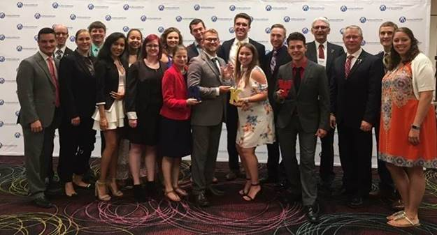

**Tiger International Experiences (Chapter 1 – Budapest, Hungary.  More summer 2017 international trips to be shared in future Dean’s Notes)**

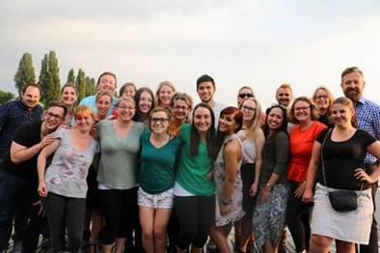

Assistant Professor of Tourism and Hospitality Karen Thal and Management Development Director Sabrina William accompanied nine students and a staff member who teaches massage therapy at FHSU to Budapest May 19-29, 2017 to study spa and thermal water management in a European context.

Budapest, Hungary as a travel destination was of interest for several reasons. Budapest Metropolitan University (BMU), which hosted our students, has an established and well-respected program in health and wellness tourism. As the health and wellness tourism program at Fort Hays State University is in its infancy, the trip was an opportunity to expose students to internationally recognized faculty as well as learn first-hand about the program that they offer. It is also no coincidence that a health and wellness tourism program was founded there. In addition to a week-long seminar series provided by BMU faculty, the trip included site visits to some of the many local spas. Known as the “City of Spas”, Budapest has an extensive system of natural hot springs, the use of which pre-dates early Roman occupation.

**CFP Board Renewal**

At the end of the spring semester, Fort Hays State University received notice that its BBA Major in Finance - Concentration in Financial Planning met or exceeded the Certified Financial Planning Board criteria for national board approval. Approval was based on FHSU coursework and faculty qualifications. The FHSU Robbins College of Business and Entrepreneurship is the only Kansas college of business with a CFP Board Registered program.

**FHSU Robbins College of Business and Entrepreneurship Part of National Millennial Community**

The National Millennial Community is less than two years young, but has already met with more than 120 corporate, foundation, governmental and civic executives (all VP and above). The purpose for the group is very simple and straightforward: to change the conversation about millennials with key influencers. The National Millennial Community gives a voice to smaller college campuses that aren't always top-of-mind with executives (who seem to only rely on the larger, bigger academic names). The Founder of the community, Bill Imada, stated, “FHSU has provided a very unique perspective on what is happening in rural America, but also in our nation's heartland. Not having that perspective would be sad for the entire community.”  Four FHSU RCOBE students will participate in this elite organization each year and are provided unique access and opportunities while sharing their perspectives as Millennials.

**FHSU Center for Economic Education and Kansas DECA**

The Center for Economic Education is supporting Kansas DECA (high school division) through a variety of innovative and engaging activities this school year.  These activities will involve over 1200 Kansas high school members.

Activities include:

* Leadership Development Workshop for Chapter Officers – hosted at Wichita State University
* Sports/Entertainment Marketing Tour/Panel – partnered with the University of Kansas Department of Sports Management and industry venues in KC (Children's Mercy Park - Sporting KC and Kansas Motor Speedway)
* Community Engagement through Promotion of Entrepreneurship and Financial Literacy – hosted/partnered by Kansas State University (College of Business & Center for Advancement in Entrepreneurship, College of Human Ecology & Institute for Personal Financial Planning, College of Education Dean's Office and CTE Ambassadors)
* Providing a New Advisor Advance to be held at the Eisenhower Presidential Library

Upcoming Event:

October 11, 2017 – School-Based Enterprises roundtable for Kansas DECA Advisors at the Capital (sponsored by Representative Fred Patton of North Topeka)

Our goal (Kansas DECA State Office / Center for Econ Ed) is to provide service and support to Kansas DECA advisors (high school business/marketing instructors) as they seek innovative ways to extend student learning opportunities.

**MBA – Finance Ranked #1 of 50 Most Affordable Online MBAs in Finance**

Fort Hays State University was ranked as #1 of the 50 Most Affordable Online MBA in Finance Degrees in Master of Finance Degrees Most Affordable Online Programs recent ranking! Based on information gathered in part from the NCES College Navigator database, schools were identified that offered master’s degrees in finance as distance education options.

Fort Hays State University, which ranked #1, was recognized in part because students engage with faculty and peers through a variety of methods including Skype, WebX, Blackboard, YouTube, and GoogleDocs.

The MBA requires courses in money, banking, financial institutions and international finance. FHSU graduates have gone to work for the U.S. Department of Agriculture, Koch Industries, International Business Machines Corporation, the Federal Deposit Insurance Corporation and General Electric. The article and a high-resolution award badge can be found here:

<http://www.master-of-finance.org/best/affordable-online-mba-finance-degree-programs/>

**#2 of 20 Best Affordable Online Bachelor’s Degrees in Hospitality Management 2017-2018**  
AffordableColleges.com named FHSU’s Bachelor of Science in Tourism and Hospitality Management as the #2 online bachelor’s program in that field for the 2017-2018 academic year. The 120-credit-hour program includes courses in general business topics as well as classes designed for students aspiring to be tourism and hospitality management professionals.  The purpose of the THM program is to provide students with the knowledge, skills, values and strategic perspectives essential to obtaining leadership roles in the hospitality service professions. According to the website, FHSU’s program stood out in both quality and affordability.  The announcement can be found at this link:  
<http://www.affordablecolleges.com/rankings/affordable-online-bachelors-hospitality-management-degrees/>

**Thank you!**

Thank you for your support and involvement. It is exciting to have students, faculty, administrators, and alumni working together to truly make great things happen. You can be proud of your college and university!

P.S.  Keep your eyes peeled for another Fort Hays State University record enrollment announcement.

Sincerely,

cid:image009.jpg@01D3312A.5941FA80

Mark Bannister, Dean  
Robbins College of Business and Entrepreneurship

101 McCartney Hall  
600 Park  
Fort Hays State University  
Hays, Kansas 67601-4099  
  
Phone:  785.628.5339  
Fax: 785.628.5398  
Email:  [markbannister@fhsu.edu](mailto:markbannister@fhsu.edu)  
Web:  <http://www.fhsu.edu/cob/>  
  
"If you want one year of prosperity, grow grain.  If you want ten years of prosperity, grow trees.  If you want 100 years of prosperity, grow people."  Old Chinese Proverb

