Virtual Student Senate

Meeting Minutes

May 3, 2021
Virtual Student Senate - Zoom (Recorded Session)
- Call to order
- Determination of Quorum
Approved
Greg Atkins (Advisor) & Haley Reiter (SGA President)
Brian Fennessy, Julie Waring, Katilin, HannahMay Baker, Jakob, Rodney Flores,
ConnorayCock, Jessica Power, Justin
- Approval of Minutes
Approved
- Reports
- President (Reiter)
Transgender bill veto(d)
New President - Mark Fabor (spelling?)

- Vice President (Waring)
No Reports
- Public Relations (Dewerff)
Gained access to webpage (names of VSS members updated)
rolling out new webpage or two for VSS (Virtual Student Senate)
Senator Dewerff got her email address for FHSU setup
Created a account with Flipgrid, for meeting storage (archives)
Facebook Page, fighting to get it done, Kelsey is working on it with Senator Dewerff)
Committee page preview

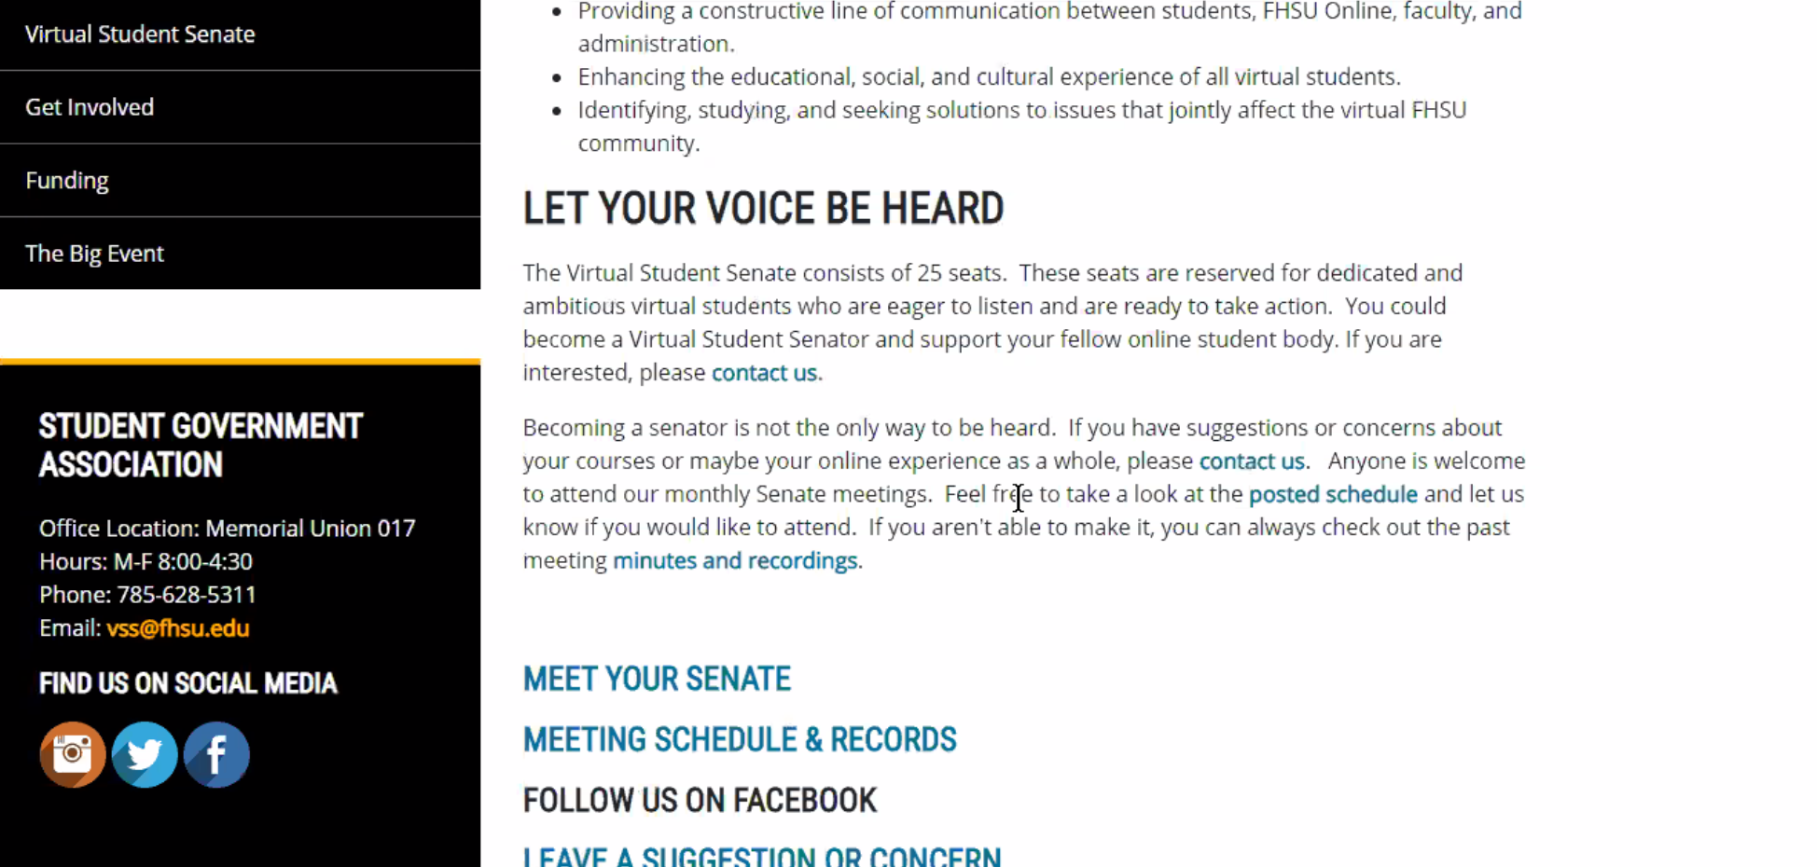
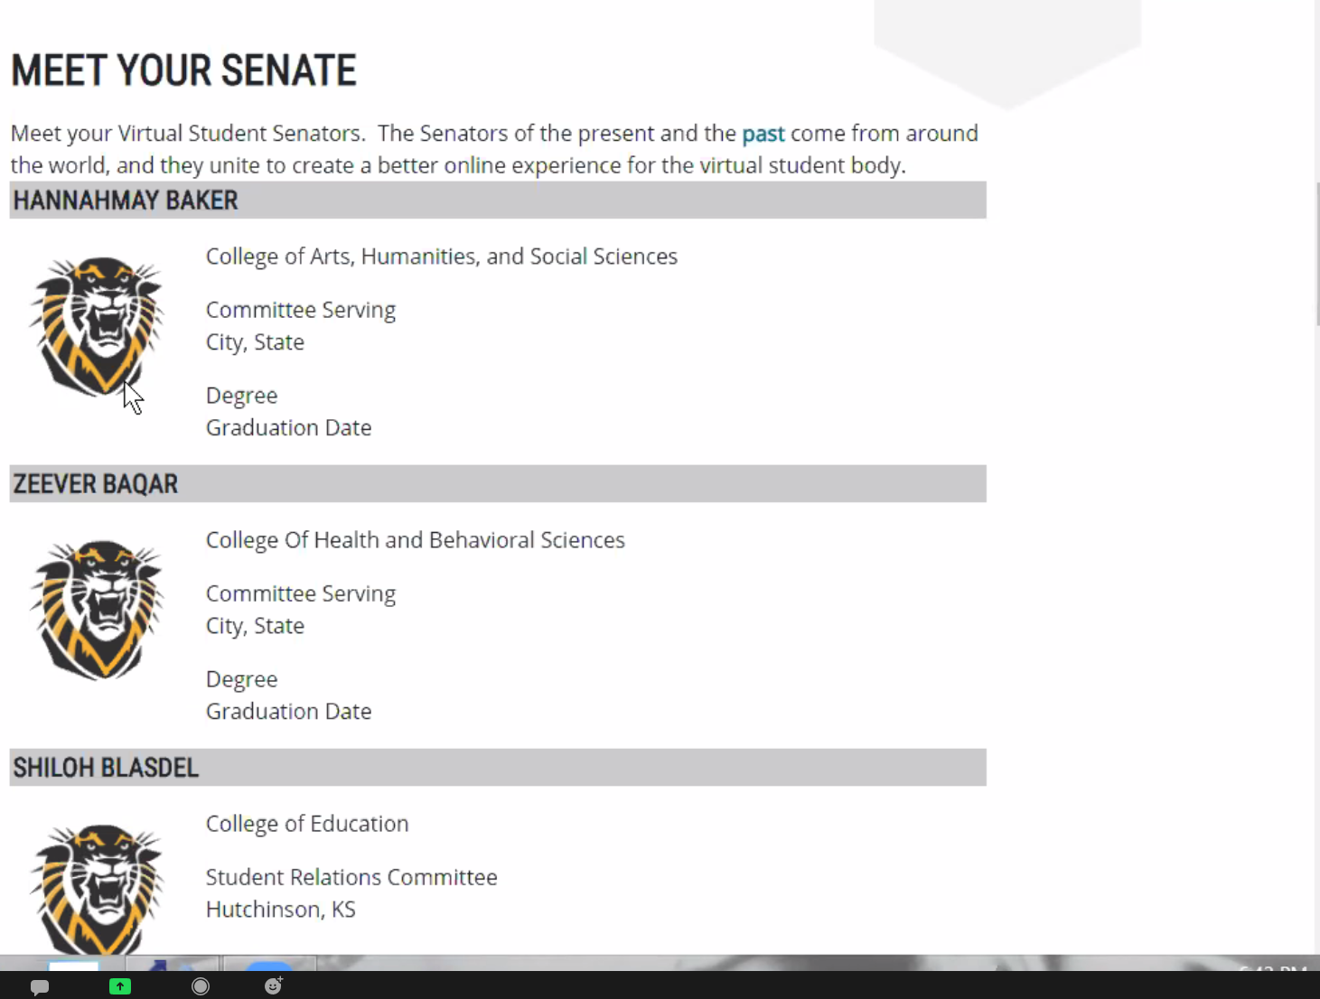

- Secretary (Fennessy)
No Reports

- Student Relations and Engagement (Flores)
Report (working with Senator Baker)
- Senate Affairs (Baker)
D&I Committee - student live reporting system - working to set-up
Heidi Pearson (Student Engagement) - she will help to promote it
for reporting issues with classes and/or instructors (anonymous reporting)
enough complaints could possibly impact instructor
Senator Baker would like to have previous changes to the Bylaws wrapped up for approval later tonight (in the meeting)
- Diversity & Inclusion (Baker)
See above (compiled)

- Virtual Channel (Fennessy)
Waiting for the new SGA President (Mark), to work with him to get the Virtual Channel going again

- FHSU Online (Atkins)
Survey for Diversity and Inclusion, went out to all faculty and students (including international partnerships)
Done by third-party company
survey will look over survey over summer, and released to VSS (in some way)
Diversity & Inclusion Advisory Committee - hoping that one of the VSS members will volunteer to join the committee. (pointing toward Senator Baker)
TILT - Teaching Inclusion & Learning Technology - for online students - Secretary Fennessy’s comments pointing out the abundance of programs and applications available and his feelings on how difficult it is for online students to navigate, TILT will be working to implement something to make this hardship better

Major assignments during university breaks (could be a resolution with faculty senate) to prevent having such assignments
- Old Business – We will limit discussion to no more than 15 minutes per item, after which we will either take action (via a motion from the floor) or table the item to our next meeting. Please do not speak unless recognized and ensure that your contribution takes the discussion forward. I will give preference to those who have not yet spoken on a topic.
- Swear-In Bill (Approved on previous meeting)
- Committee Archival Responsibilities Bill (Approved on previous meeting)
- Committee Extension Bill
https://docs.google.com/document/d/1eM7EStXlVg8bB2tpk3JK5DQNDkbEpfV_3iN1IjBeGcY/edit?ts=608c69d6&skip_itp2_check=true

Diversity & Inclusion Committee Permanent - Baker says:
we should rename committee
Create Equity & Inclusion Committee (I.E., reword Diversity & Inclusion Committee)

Senator Kaitlin’s Public Relations Position & Committee amendments are approved by Senate

Motion to approve grammatical changes by senator Jakob Curatola-Wozniak
for Senator Baker’s bills:
https://docs.google.com/document/d/1fXHtOGUEVgRQsfqUKAUdMaB4dPhVzoo4HYcT7vdW2ak/edit?ts=608c6ea3

- New Business
Connor Raycock - pledge read by Senator Baker (he pledged)
Senator Connor is now a voting member.
- Open Forum
Vice President Waring -
Proposed 2021/2022 - discuss electing existing body for “continuity” of VSS to keep a smooth transition for senate.
Motion to elect executive counsel -
Vice President Waring - approved as Vice-President
Secretary - nomination Justin Schwab Brian Fennessy
New secretary is … Justin Schwab
Public Relations - Kaitlin approved
Adjournment
Motion to Adjourn - Approved

