Fort Hays State University
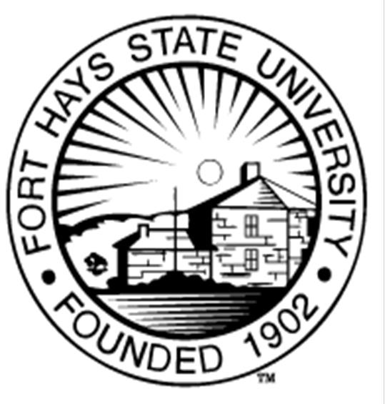

Council for the Accreditation of Counseling and Related Educational Programs (CACREP)
Vital Statistics Report December 2025

Accredited programs:
School Counseling (M.S. Degree)
Clinical Mental Health Counseling (M.S. Degree)

Paul Adams, PhD
Dean, College of Education

Kim Chappell, EdD
Chair, Department of Advanced Education Programs

Reade Dowda, PhD, LPC
CACREP Liaison/Associate Professor and Coordinator of the Clinical Mental Health Counseling Program

Sarah Lancaster, PhD, LPC
Associate Professor and Coordinator of the School Counseling Program

Advanced Education Programs
Rarick Hall
Fort Hays State University
600 Park Street
Hays, Kansas 67601

Fort Hays State University
Counseling Programs – Department of Advanced Education Programs Vital Statistics Report 2024-2025
Each year, the counseling programs provide vital statistics to inform all interested parties and prospective students of the changes and progress made in the school counseling and clinical mental health counseling programs. The statistics inform student progress and outcome while achieving an MS Degree in counseling from Fort Hays State University (FHSU). The following information is from the 2024-2025 Academic Year.

School Counseling Program

This past academic year, there were 39 graduates of the FHSU MS in School Counseling Program. To obtain initial licensure, our graduates complete the Praxis II: Professional School Counselor. Licensure examination data is not openly available to the FHSU faculty; therefore, we rely on reporting from our graduate survey and estimates from advisors. This past year, the estimated pass rate was 100% for our graduates taking the Praxis II. Of all the graduates actively seeking employment, there was a 100% job placement rate.

Currently, there are 120 students enrolled in the School Counseling program for the Fall 2025. The School Counseling program received 68 applications last academic year. Ninety-seven percent of students graduated within the expected time period of three years for full time students. Course offerings and enrollment requirements accommodate both part-time and full-time students.

Clinical Mental Health Counseling Program

This past academic year, there were 18 graduates of the FHSU MS in Clinical Mental Health Counseling Program. Graduates complete the National Counselor Examination (NCE) for LPC licensure. Licensure examination data is not openly available to the FHSU faculty; therefore, we rely on reporting from our graduate survey and estimates from advisors. This past year, the estimated pass rate was 100% for our graduates taking the NCE. Of all the graduates actively seeking employment, there was a 100% job placement rate.

Currently, there are 111 students enrolled in the Clinical Mental Health Counseling program for Fall 2025. The Clinical Mental Health Counseling program received 134 applications last academic year. Ninety-five percent of the students graduated within the expected time period of three years for full-time students. Course offerings and enrollment requirements accommodate both part-time and full-time students.

SCHOOL COUNSELING PROGRAM

Applicant Statistics

Statistic 2024-2025
Number of Students Enrolled* | 120
Average Class size
Content Class | 8.62
Practicum | 8
Internship | 10.63
Number of Graduates
Completion Rate** | 97%
CPCE Pass Rate | 100%
Licensure Pass Rate*** | 100%
Job Placement Rate*** | 100%

*Students enrolled for Fall 2025.

**Completion rate is based on reports from Workday, FHSU’s student information system software. We rely on enrollment reports and estimates from advisors.

***Numbers represent the number of graduates who responded to the graduate survey and estimates from advisors. The numbers for job placement rate and NCE pass rate do not reflect the entire graduates of the program.

CLINICAL MENTAL HEALTH COUNSELING PROGRAM

Current Statistics

Statistic 2024-2025
Number of Students Enrolled* | 111
Average Class size
Content Class | 8.62
Practicum | 9.67
Internship | 7.8
Number of Graduates
Completion Rate** | 95%
CPCE Pass Rate | 100%
Licensure Pass Rate*** | 100%
Job Placement Rate*** | 100%

*Students enrolled for Fall 2025.

**Completion rate is based on reports from Workday, FHSU’s student information system software. We rely on enrollment reports and estimates from advisors.

***Numbers represent the number of graduates who responded to the graduate survey and estimates from advisors. The numbers for job placement rate and NCE pass rate do not reflect the entire graduates of the program.

Applicant Statistics SCHOOL COUNSELING
Statistic 2024-2025
Applicants | 68
Accepted | 47

CLINICAL MENTAL HEALTH COUNSELING

Statistic 2024-2025
Applicants | 134
Accepted | 74

Aptitude for graduate level education is assessed in the applicant interview, undergraduate GPA, letters of recommendation and personal goal statement.

Summary of Findings
The counseling programs continue to pursue meeting the demand for counselors in the state of Kansas. The Counseling Programs recently transitioned two non-tenure track faculty to tenure track. We hired two new non-tenure track faculty members to maintain compliance with the core to adjunct ratio while providing more classes for students to effectively navigate the programs in a timely manner. The counseling programs met the CACREP FTE requirements. The student to faculty ratio for academic year 2024 – 2025 was 11.49:1. The core faculty taught more than 51% of the course offerings.
Both the School Counseling and the CMHC programs continue to grow in enrollment, partly to meet the demands of Kansas Schools and prevalence of alternative licensure pathways. The programs receive many applications each year, and the number of qualified candidates continues to be high as well. Applicants to the programs are majority White and female.
Reported licensure pass rates are 100% and the job acceptance rates are 100% for those seeking employment. For those seeking doctoral admission, the reported acceptance rate was 100%. The state of Kansas continues to desire counselors. The Kansas Department of Education (KSDE) has indicated a goal to hire on average 150 school counselors each year through 2024 so they can achieve a 250:1 counselor to student ratio across public schools.

