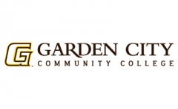
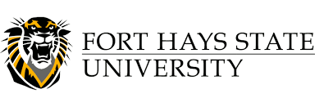

2020 NACTA Meats Contest
Hosted by Garden City Community College
For Fort Hays State University

Wednesday, April 1st - 9:30 a.m.
Garden City Community College Meat Science Lab

Contest Director:
Dr. Clint Alexander
(620) 272 – 4370
clint.alexander@gcccks.edu

Contestants will need only a clipboard and pencil to bubble scantron forms, which will be provided by GCCC for scoring. GCCC will provide any cooler coats, frocks, hair nets, etc., for the competition so that teams do not have to bring them. The format will be as follows:

Classes (300 points):
Beef Short Loins
Beef Ribs
Beef Retail Cuts
Pork Carcasses
Pork Hams
Pork Loins

Questions (50 points): 2 classes (one each of beef and pork) will have questions, 5 questions per class each worth 5 points for a total of 10 questions or 50 points.

USDA Quality and Yield Grading (100 points): 5 head will be evaluated for USDA Quality and Yield Grades. Sides will be quartered, weights and % of Kidney, Pelvic and Heart fat will be given.

Retail Identification (210 points): 30 retail ID cuts from a wide range of beef, pork and lamb will be evaluated using the National FFA retail ID form and cuts. The National FFA scoring system will be used: Species = 1 point, Wholesale cut = 2 points, retail cut name = 3 points, cookery = 1 point. All exhibits will be either in vacuum seal (for larger cuts) or wrapped with tray/overwrap system. You can use the cuts from page 18-19 on the attached meat evaluation form from the National FFA organization.

