NACTA Soil Judging Contest Handbook
2 Year Division

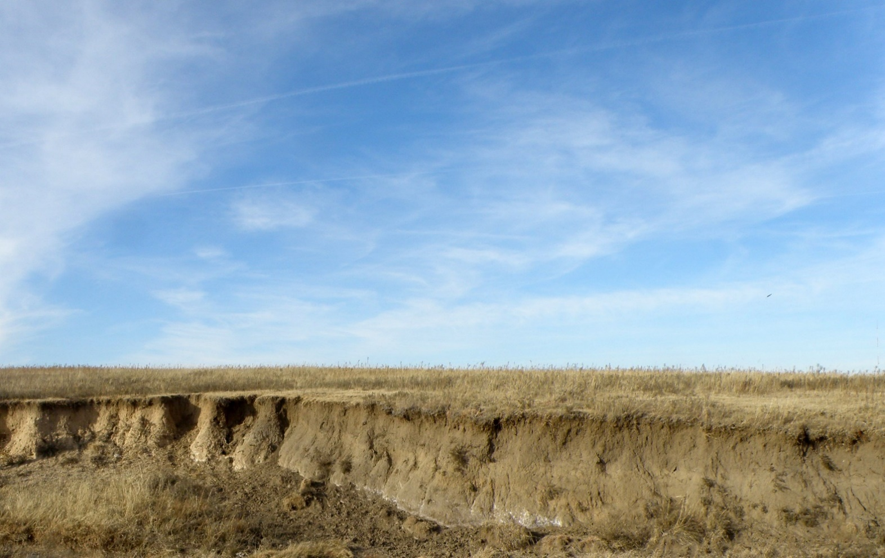

Fort Hays State University
April 3, 2020

Modified from previous versions prepared by the Soil Judging Coaches and Official Judges of NACTA and Region 5

Version 1.0 12/19/19
PREFACE
This handbook provides information about the 2020 NACTA Soil Judging Contest for the 2 Year Division. This manual provides the rules, scorecard instructions, and additional information about the contest. Much of the material comes from previous handbooks, with some modification. The handbook has been adapted to the soils and landscapes of Kansas. Other references used to develop this handbook include: Chapter 3 of the Soil Survey Manual (Soil Survey Division Staff, 2017), Field Book for Describing and Sampling Soils, version 3.0 (Schoeneberger et al., 2012), Soil Taxonomy (Soil Survey Staff, 1999), Keys to Soil Taxonomy 12th Edition (Soil Survey Staff, 2014), Illustrated Guide to Soil Taxonomy (Soil Survey Staff, 2014), and National Soil Survey Handbook (Soil Survey Staff, 2011). In keeping with recent contests, emphasis is placed on fundamentals such as soil morphology and soil-landscape relationships.

We welcome the teams to Hays, KS and hope the contest provides both an educational and rewarding experience. Many thanks to those who helped with preparations and funding for this event. The contest is hosted by Fort Hays State University and the USDA-NRCS. We thank the volunteers and landowners that made this event possible.

Andrew Tucker, FHSU
Office Phone: 785-628-4010
E-mail: antucker@fhsu.edu

Don Benjamin, FHSU
Office Phone: 785-628-4368
E-mail: drbenjamin@fhsu.edu

Kevin Huser, FHSU
Office Phone: 785-628-5880
E-mail: kfhuser3@fhsu.edu

Chad Remley, USDA-NRCS
Office Phone: 785-823-4564
E-mail: chad.remley@usda.gov

John Warner, USDA-NRCS
Office Phone: 785-823-4559
E-mail: john.warner2@usda.gov

Ryan Still, USDA-NRCS
Office Phone: 758-624-3140
E-mail: ryan.still@usda.gov

Laura Bricknell, USDA-NRCS
Office Phone: 785-624-3140
E-mail: laura.bricknell@usda.gov

Figure 1. Physiographic regions and vegetation map of Kansas.
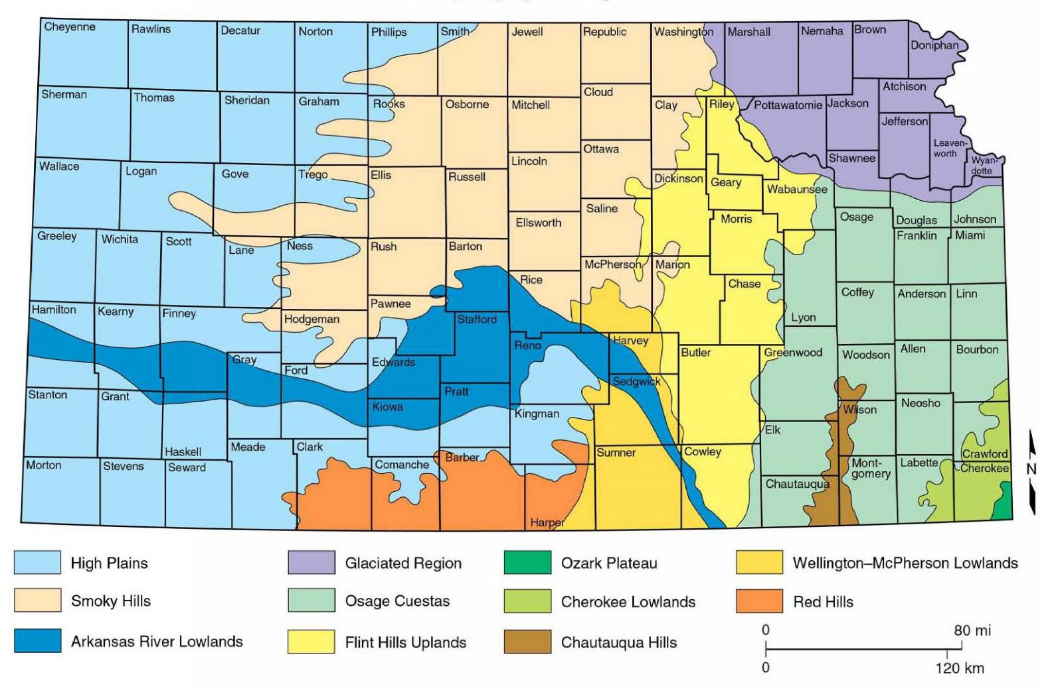

INTRODUCTION

Soil judging provides an opportunity for students to study soils through direct experience in the field. Students learn to describe soil properties, identify different kinds of soils and associated landscape features, and interpret soil information for agriculture and other land uses. These skills are developed by studying a variety of soils formed from a wide range of parent materials and vegetation in different topographic settings. Students gain an appreciation for soil as a natural resource by learning about soils and their formation. We all depend on soil for growing plants, crops, and range for livestock; building materials; replenishing water supplies; and waste disposal. If we do not care for our soils, loss of productivity and environmental degradation will follow. By understanding more about soils and their management through activities like soil judging, we stand a better chance of conserving soil and other natural resources for future generations.

Students in soil judging participate in contests held annually in different locations. These contests are an enjoyable and valuable learning experience, giving students an opportunity to obtain a first-hand view of soils and land use outside their home areas.

This handbook is organized into several sections that describe the format and content of the contest. The contest involves soil description and interpretation at sites by students, who record their observations on a scorecard (see Appendix). The sections of content follow the organization of soil and related information given on the scorecard. Those sections include morphology, site and soil characteristics, and interpretations.

CONTEST RULES, SCORING, AND PROCEDURES

The contest will be held on Friday, April 3, 2020 and will consist of four sites. At each site, a pit will be excavated, and two control areas will be designated for the measurement of horizon depths and boundaries. The control area will constitute the officially scored profile and must remain undisturbed and unblocked by contestants. A tape measure will be fixed within the control area.

The site number, number of horizons to be described, the profile depth to be described, and any additional information or laboratory data deemed necessary for correct classification will be provided to each contestant for that pit. A maximum of six horizons will be described at each pit. A marker (e.g., nail) will be placed at the bottom of the third horizon. A pit/site monitor at each site will enforce the rules, answer any questions, keep time limits, clean soil from the base of the pit as needed and/or requested, and assure all contestants have an equal opportunity to judge the soil.

- Each team will consist of four (4) members judging four (4) sites. Four (4) alternates may accompany the team and compete for individual awards only. The top three (3) scores per site will be used to tabulate team scores.

- A tiebreaker system for individuals will involve estimates of the percent sand and clay for the surface horizon. Ties will be broken using the estimates in the order of clay then sand. Individual total score ties will be broken by using site scores in pit order (i.e. pit 1, then pit 2, etc.) Tabulating all four (4) members’ cumulative scores will break team ties.

- Contestants will be allowed Fifty (50) minutes to judge each site. The time in and out of the pit will be as follows: 10 minutes in/out, 10 minutes out/in, 10 minutes in/out, 10 minutes out/in, and 10 minutes free time for all to finish. The contestants who are first “in” and “out” will switch for the next pit to allow equal opportunity for all contestants to be first in or first out. NOTE: This timing schedule may be modified depending on the number of teams and contestants participating. However, each individual will have at minimum 50 minutes at each site.

- Contestants may use a clipboard, hand level, containers for soil samples, pencil (no ink pens), knife, water and acid bottles, Munsell color book (Hue 10R to Hue 5Y, Gley 1 & 2), and ruler or tape (metric preferred since all depths will be in cm). A textural triangle may be used to assist contestants in completing the percent sand, silt and clay tiebreaker. Triangles will be supplied at the contest. One is enclosed for your use prior to the contest in Attachment 1. A 2 mm sieve for estimating rock fragments may be used. Rating charts, but not their written explanations, for use in the interpretations section of the scorecard will be supplied at each site. You do not have to memorize the charts, but you should know how to use them.

- In each pit, a control zone will be clearly marked and is to be used only for the measurement of horizon/layer depths boundaries. This area will be the officially scored profile and must not be disturbed. The profile depth to be considered, number of layers to be described, and any other relevant data, will be provided at each site. A marker will be placed somewhere in the third layer to assist contestants in keeping in line with the official description. The depth in centimeters from the surface to the marker will be given on the site card.

- Stakes with flagging will be set near each site for slope measurement. Slopes will be measured between the stakes that are set at approximately the same height.

- Contestants will not be allowed to communicate with other contestants or coaches during the contest. No cell phones.

- Pit monitors will be present to enforce rules and keep time. The official judges for the contest will be NRCS soil scientists.

- Each contestant must give his or her score card to the pit monitor before moving to the next site. Write your name, contestant number, college, and site number on each card. Use abbreviations for all columns except depth.

SCORE CARD INSTRUCTIONS

.

- SOIL MORPHOLOGY: In each pit, you will be asked to evaluate up to six horizons, and describe them using standard terminology. The number of horizons to be judged will be on a card at each pit. For each horizon, evaluate layer depth, boundary distinctness, texture, rock fragments, color, structure, moist consistency, and accumulations. Be sure to write clearly. Then, based on your understanding of soils, your description, and these instructions, complete the back side of the score card (Parts II and III). A complete list of acceptable abbreviations is in these instructions.

- HORIZON: (See SSM (2017) ch3-91-99) Students should label each layer with the abbreviation for one mineral genetic horizon/layer (A, B, C, E, or R). If a horizon is a transitional horizon (e.g. AB, BA) or a combination horizon (e.g. A/B, B/A), students should record the genetic horizon whose properties dominate the layer (e.g. an AB or A/B would be A, a BA or B/A would be B). Official judges may decide to allow more than one correct answer for such horizons.

  - A Horizon – Horizon formed at the surface that exhibits either an accumulation of humified organic matter, or properties resulting from cultivation or pasturing.
  - E Horizon – Horizon in which the main feature is loss of silicate clay, iron, aluminum, or some combination of these, leaving a concentration of sand and silt particles.
  - B Horizon – Horizon formed below an A or E, that shows one or more of the following: illuvial concentration of silicate clay, iron, aluminum, humus, carbonates, gypsum, or silica; evidence of removal of carbonates; residual concentration of sesquioxides; coatings of sesquioxides; alteration that forms silicate clay or liberates oxides and forms granular, blocky, or prismatic structure; or brittleness.
  - C Horizon – Horizons, excluding hard bedrock, that are little affected by pedogenesis and lack properties of A, B, or E horizons.
  - R Layer – Hard bedrock. The layer is sufficiently coherent when moist to make hand digging with a spade impractical.

- DEPTH: (see SSM (2017) ch3-118-119) Horizon depths often cause problems. In order for the students and judges to have a common base, we will use the following guidelines.
Up to six horizons will be described within a specified depth. You should determine the depth in cm, from the soil surface to the lower boundary of each layer. Thus, for a layer that occurs 23-37 cm below the surface, you should enter 37. To receive credit for the last horizon’s lower boundary, students are to write down the lower depth given on the site card. Depth measurements should be made in the control zone. The allowed range for answers will depend on the distinctness, and to a lesser degree, the topography of the boundary, as determined by the judges.

Please note the following: If a lithic or paralithic contact (hard or soft bedrock) occurs anywhere in the exposed control zone (within 150 cm) you will need to consider it in answering several sections in Part II as well as in any rating charts used in Part III. This is true even if the contact is at, or below, the specified description depth, and not an actual horizon in your profile description. If such a situation arises, assume your last horizon’s properties extend to the contact. Be sure and note the contact depth, while you are in the pit, even if it is below the description depth.

If the contact is within the specified description depth, it should be indicated on the score card. Morphological features need not be recorded for Cr or R horizons. If they are, graders will ignore them and no points will be deducted.

- DISTINCTNESS OF BOUNDARY: The distinctness of horizon boundaries is to be evaluated as described in SSM (2017) ch3-112. The distinctness of the lower boundary of the last layer is not to be determined and the contestant is to mark none (-) as the boundary distinctness to receive credit. The topography, or shape, of the boundaries will not be directly considered, but it could influence contest officials.

As a guide, the following system will relate distinctness of boundary for full credit.

Distinctness Abbreviation Lower Depth Range

Abrupt | A | +/- | 1 cm
Clear | C | +/- | 3 cm
Gradual | G | +/- | 8 cm
Diffuse | D | +/- | 15 cm

This method of determining full credit may be modified on a given site by contest officials.

- COLOR: (See SSM (2017) ch3-145-155)
Munsell soil color charts are used to determine the moist soil matrix color for each horizon described. Color must be designated by hue, value, and chroma. Space is provided to enter the hue, value, and chroma for each horizon separately on the scorecard. At the discretion of the official judges, more than one color may be given full credit. Color is to be judged for each horizon by selecting soil material to represent that horizon. The color of the surface horizon will be determined on a moist, rubbed (mixed) sample. For lower horizons (in some soils this will also include the lower portion of the epipedon), selected peds should be collected from near the central part of the horizon and broken to expose the matrix. If peds are dry, they should be moistened before the matrix color is determined. Moist color is that color when there is no further change in soil color when additional water is added. For Bt horizons with continuous clay films, care should be taken to ensure that the color of a ped interior rather than a clay film is described for the matrix color.

- MOIST CONSISTENCE: (see SSM (2017) ch3-180-185)
Soil consistence refers to the resistance of the soil to deformation or rupture at a specified moisture level and is a measure of internal soil strength. Consistence is largely a function of soil moisture, texture, structure, organic matter content, and type of clay, as well as adsorbed cations. As field moisture will affect consistence, contestants should use their personal judgment to correct for either wet or dry conditions on the day of the contest. These corrections also will be made by the official judges. Contestants should judge the consistence of moist soil (midway between air-dry and field-capacity) for a ped or soil fragment from each horizon as outlined in the Field Book for Sampling and Describing Soils, 2012 and Table 1.
Table 1. Soil moist consistencies, symbols and descriptions.

Consistence | Symbol | Description
Loose | L | Soil is non-coherent (e.g., loose sand).
Very friable | VFR | Soil crushes very easily under very slight force (gentle pressure) between thumb and finger but is coherent when pressed.
Friable | FR | Soil crushes easily under slight force (gentle to moderate pressure) between thumb and forefinger and is coherent when pressed.
Firm | FI | Soil crushes under moderate force (moderate pressure) between thumb and forefinger, but resistance to crushing is distinctly noticeable.
Very firm | VFI | Soil crushes or breaks only when strong force is applied between thumb and all fingers on one hand.
Extremely firm | EF | Soil cannot be crushed or broken by strong force between thumb and all fingers but can be by applying moderate force between hands.
Slightly rigid | SR | Soil cannot be crushed by applying moderate force between hands but can be by standing (entire body weight on one foot) on the structural unit.
Rigid | R | Soil cannot be crushed by standing on it with one body weight but can be if moderately hit with hammer.
Very Rigid | VR | Soil requires heavy, strong blow(s) with hammer to crush.

- ROCK FRAGMENTS: (see SSM (2017) ch3-131-137)
Rock Fragment modifiers should be used if a layer’s rock fragment content is > = 15% by volume. This modifier should be listed on the score card. Do not enter your numerical volume estimate. The following abbreviations should be used:

% Volume Modifier Abbreviation

0 - <15% | None | -
15 - <35% | Gravelly | GR
35 - <60% | Very Gravelly | VGR
≥ 60% | Extremely Gravelly | XGR
- TEXTURE : Texture for each horizon should be designated as one of the 12 basic textural classes, listed in SMM 3-136-140. Textural class names are to be abbreviated. The following are the correct abbreviations for textural classes:

S | Sand | CL | Clay Loam
LS | Loamy Sand | SICL | Silty Clay Loam
SL | Sandy Loam | SCL | Sandy Clay Loam
L | Loam | SC | Sandy Clay
SI | Silt | SIC | Silty Clay
SIL | Silt Loam | C | Clay

- STRUCTURE: (See SSM (2017) ch3-155-161) Record the dominant type (shape) of structure for each layer. Single grain and massive are terms for structureless soils, but they are included under shape. Single grain material has only loose mineral grains present and is basically non-cohesive. Massive material has no structural arrangement, but is coherent, and when the soil is broken out, it consists mainly of fragments and some mineral grains. If different types of structure occur in different parts of the layer, give the type of the one that is prevalent. If a horizon has compound structure (i.e., prismatic parting to angular blocky), give the primary structure. Table 2 contains a list of structure types and their abbreviations:

Table 2. Soil structure types, symbols and descriptions.

Type | Symbol | Description
Granular | GR | Spheroids or polyhedrons bounded by curved planes or very irregular surfaces, which have slight or no accommodation to the faces of surrounding peds. For the purposes of this contest crumb structure is included with granular structure.
Subangular blocky | SBK | Polyhedron-like structural units that are approximately the same size in all dimensions. Peds have mixed rounded and flattened faces with many rounded vertices. These structural units are casts of the molds formed by the faces of the surrounding peds.
Angular blocky | ABK | Similar to subangular blocky but block-like units have flattened faces and many sharply angular vertices.
Platy | PL | Plate-like with the horizontal dimensions significantly greater than the vertical dimension. Plates are approximately parallel to the soil surface. Note: this does not apply to weathered rock structure.
Wedge | WEG | Elliptical, interlocking lenses that terminate in acute angles, bounded by slickensides. Wedges are not limited to vertic materials.
Prismatic | PR | Prism-like with the two horizontal dimensions considerably less than the vertical. Vertical faces are well defined and arranged around a vertical line with angular vertices. The structural units have angular tops.
Columnar | COL | Same as prismatic but with rounded tops or caps.
Massive | MA | No structure is apparent and the material is coherent. The individual units that break out of a profile have no natural planes of weakness.
Single grain | SGR | No structure is apparent. Soil fragments and single mineral grains do not cohere (e.g., loose sand). In some cases where weak cohesive/adhesive forces with water exist, some seemingly cohesive units can be removed. However, under very slight force, they fall apart into individual particles.

- Soil Features (Redox Concentrations and Depletions and Matrix Concentrations)

Redoximorphic Features
Redoximorphic (redox, RMF) features are caused by the reduction and oxidation of iron and manganese associated with soil wetness/dryness and not rock color. Characteristic color patterns are created by these processes. Redox features are colors in soils resulting from the concentration (gain) or depletion (loss) of pigment when compared to the soil matrix color. Reduced iron (Fe2+) and manganese (Mn2+) ions may be removed from a soil if vertical or lateral fluxes of water occur. Wherever iron and manganese is oxidized and precipitated, they form either soft masses or hard concretions and nodules. Redox features are used for identifying aquic conditions and determining soil wetness class. For this contest, only the presence or absence of redoximorphic features (Y or N [will also allow a dash]) in terms of redox concentrations and redox depletions will be evaluated. Movement of iron and manganese as a result of redox processes in a soil may result in redoximorphic features that are defined as follows:

a. Redox concentrations – These are zones of apparent pedogenic accumulation of Fe-Mn oxides, and include: nodules and concretions (firm, irregular shaped bodies with diffuse to sharp boundaries; masses (soft bodies of variable shapes in the soil matrix; zones of high chroma color (“red” for Fe and “black” for Mn); and pore linings (zones of accumulation along pores). Dominant processes involved are chemical dissolution and precipitation; oxidation and reduction; and physical and/or biological removal, transport and accrual.
Presence: Yes (Y) RMF concentrations are present
No (N, or -) RMF concentrations are not present

b. Redox depletions – These are zones of low chroma (2 or less) and normally high value (4 or more) where either Fe-Mn oxides alone or Fe-Mn oxides and clays have been removed by eluviation.
Presence: Yes (Y) RMF depletions are present
No (N, or -) RMF depletions are not present

The color of the redox feature must differ from that of the soil matrix by at least one color chip in order to be described. For determination of a seasonal high water table, depletions of chroma 2 or less and value of 4 or more must be present. If this color requirement is not met, the depletions should be described, but the depletions do not affect the soil wetness class or site interpretations. Low chroma (≤ 2) in the soil may be due to drainage, parent material, or other features. However, parent material variations and other such features should not be considered in evaluating soil wetness or soil drainage characteristics. Colors associated with the following features will not be considered as redox features: carbonates, concretions, nodules, krotovina, rock colors, roots, or mechanical mixtures of horizons such as B horizon materials in an Ap horizon. If no redox features are present, enter an “N” or dash. Specific definitions may be found in Soil Taxonomy (1999) in the “Aquic Conditions” section of “Other Diagnostic Soil Characteristics.”

Matrix Concentrations
These are visible pedogenic concentrations that can occur in the soil matrix (including soft, non-cemented masses or other bodies; excluding soft rock fragments) for each horizon.. Concentrations are identifiable bodies found in the soil matrix. They contrast sharply with surrounding soil material in terms of color and composition. Water movement and the extent of soil formation can be related to concentration location and abundance within the soil profile as well as orientation within a horizon. For this contest, only the presence of concentrations will be determined. In the contest area, four types of concentrations (based on composition) can occur: carbonates, gypsum, other salts, and iron-manganese.
Presence: Yes (Y) matrix concentrations are present
No (N, or -) matrix concentrations are not present

- SITE AND SOIL CHARACTERISTICS

  - LOCAL LAND FORM: (May be modified by Host Institution) Select the local land form of the site from the choices on the score card. In a situation where two parent materials are present, the land form will be selected on the basis of the process that controls the shape of the landscape. In most cases, this will be the lower parent material. For example, if alluvium is underlain by residuum which is exposed in the pit, then an upland land form should be used. Only one land form is to be identified at each site. Select the one that best describes the situation. Dual credit may be awarded by the contest officials.

Table 3. Landforms found in Kansas and their descriptions.

Landform | Description
Upland | Upland refers to geomorphic landforms, not otherwise designated, that are generally above present-day valleys and which may be underlain by bedrock or sediments of glacial, eolian, or colluvial/pedisediment materials.
Upland depression | A closed basin within an upland that is not directly connected to an integrated surface drainage system. Surface accumulations of organic- enriched soil and redoximorphic features are commonly found in these areas, but are not necessary for identification.
Alluvial fan | A body of alluvium whose surface forms a segment of a cone (fan-shaped in plan view) that radiates downslope from the point where a stream emerges from a narrow valley into a broader valley.
Stream terrace | A step-like surface or platform along a stream valley that represents a remnant of an abandoned floodplain. Where occurring in valley floors, this landform is commonly smooth, having low relief, and may or may not be dissected by an under-fitted stream. It consists of a relatively level surface, cut or built by a stream and a steeper descending slope (scarp or riser) and can contain the hillslope position of footslope.
Floodplain | A nearly level alluvial plain that borders a stream and is subject to flooding unless artificially protected. The floodplain refers to the lowest level(s) associated with a stream valley and is sometimes referred to as bottom soil, stream bottom, or first bottom. Sediments may or may not be stratified. Soils found in a floodplain position normally have little profile development beneath the A horizon. If coarse fragments are present, they are normally rounded or subrounded.
Paleoterrace | An erosional remnant of a terrace which retains the surface form and alluvial deposits of its origin but was not emplaced by, and commonly does not grade to a present-day stream or drainage network.
Dunes/Interdunes | Stabilized rolling hills, dunes, and intermittent valleys between the hills and dunes. The hills are mostly round-topped or conical and smooth. The dunes can be in distinct ridges, or they can be very choppy. Some portions of this landscape have an irregular appearance. If present, this landform will take precedence over “upland”, “upland depression”, and “footslope” in the contest.

  - PARENT MATERIAL: (May be modified by Host Institution) Mark the appropriate parent material from the list on the score card. Contestants must identify the parent material(s) with each profile. If more than one parent material is present, all should be recorded; dual and/or partial credit may be awarded. For this contest, a parent material should be >30 cm thick if it is on the surface or >10 cm thick if at least 30 cm below the soil surface to be indicated on the scorecard. Multiple parent materials are common for the soils of Kansas (Table 4). A different parent material should also be indicated if it is present in the last horizon of the described profile. Parent materials, like soils, do not always lend themselves to easy classification, so the contest officials may need to take the complexity of the situation into account in scoring alternative interpretations. The following are definitions of parent materials.

Table 4. Parent materials found in Kansas and their descriptions.

Parent Material | Description
Alluvium | Alluvium consists of sediment transported and deposited by running water and is associated with landforms such as floodplains and stream terraces. As running water sorts sediment by particle size, these materials are often stratified. Rock fragments are often rounded in shape. Alluvium may occur on terraces above present streams (old alluvium) or in the normally flooded bottomland of existing streams (recent alluvium). The sediments may be of either a general or local origin. For this contest, contestants will not differentiate between old and recent alluvium.
Colluvium/  Pedisediment | Colluvium/pedisediment consists of sediment that has accumulated on hillslopes, usually but not always near the base of slopes (i.e., footslopes), in depressions, or along small upland intermittent streams. This material is unconsolidated material transported or moved by gravity and by local, unconcentrated runoff that accumulates on or near the base of the slopes. The sediment is typically a poorly sorted mixture of particle sizes. These materials can occur on summits, shoulder slopes, and backslopes as well as footslope positions. The material is of local origin.
Eolian Sand/ Eolian Loam | Eolian sand/eolian loam consists of sandy and loamy sediments transported and deposited by wind. Eolian sand is associated with sand dunes of varying size and shape. Eolian loam is associated with transition areas where eolian sand and loess parent materials are in close proximity.
Loess | Loess consists of silty-textured, wind-deposited sediment that is dominantly of silt-size. Loess may contain significant amounts of clay and very fine sand, depending on the distance from the loess source. Some loess near the source may contain more sand than would be expected due to local fluvial action and/or reworking by the wind. Thin loess deposits over residuum or colluvium can have up to 15% rock fragments.
Residuum | Residuum is bedrock that has weathered in place into an unconsolidated state. Rock fragments tend to be oriented in relation to the fabric of the bedrock. Bedrock types observed in the contest area typically include limestone and shale..

  - SLOPE: (see SSM ch2-40-46) Slope refers to the inclination of the ground surface and has length, shape, and gradient. Gradient is usually expressed in percent slope and is the difference in elevation, in length units, for each one hundred units of horizontal distance. Slope may be measured by an Abney level or by a clinometer. Slope classes are based on the gradient. The percentage limits for slope classes are indicated on the scorecard and below in table 5. Stakes or markers will be provided at each site for determining slope and the slope should be measured between these two markers. The tops of the markers will be placed at the same height, but it is the responsibility of the contestant to make sure that they have not been disturbed. If the slope measurement falls on the boundary between two slope classes, contestants should mark the steeper class on the scorecard. Contestants may want to write the actual slope value in the margin of the scorecard to aid in the completion of the interpretations section.

Table 5. Slope classes used in this contest.

Concave
0% - <2%
2% - <5%
5% - <10%
10% - <15%
15% - <25%
≥25%

  - HILLSLOPE PROFILE POSITION
Hillslope position (Figure 2, from R. V. Ruhe. 1969. Quaternary Landscapes in Iowa, p 130-133) represents the geomorphic segment of the topography on which the soil is located (Table 6). These slope components have characteristic geometries and greatly influence soils through differences in slope stability, water movement, and other slope processes. Not all profile elements may be present on a given hillslope. The landscape unit considered when evaluating hillslope profile position should be relatively large and include the soil pit and/or the area between the slope stakes. Minor topographic irregularities are not considered for this contest. Note that you could also have a backslope and a footslope component in an upland depression. Illustrations of simple hillslope profile components can be found in Figure 2.

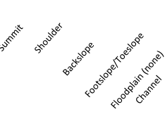

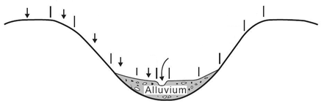

Figure 2. Hillslope profile components, as modified from Ruhe, 1969.

Table 6. Hillslope profile positions recognized in this contest and their general descriptions.

Hillslope position | Description
Summit | Highest level of an upland landform with a relatively gentle, planar slope. The summit is often the most stable part of a landscape. If the site is on a summit and has a slope < 2%, the summit position on the scorecard should be selected. Not every hillslope has a summit, as some hillslopes have shoulders at the crest of the hill.
Shoulder | Rounded (convex-up) hillslope component below the summit. The shoulder is the transitional zone from the summit to the backslope and is erosional in origin.
Backslope | Steepest slope position that forms the principal segment of many hillslopes. The backslope is commonly linear along the slope, is erosional in origin, and is located between the shoulder and the footslope positions.
Footslope | Slope position at the base of a hillslope that is commonly rounded, concave-up along the slope. The footslope is transitional between the erosional backslope and depositional toeslope. Accumulation of sediments often occurs within this position.
Toeslope | Lowest landform component that extends away from the base of the hillslope. If the site is a toeslope and has a slope of < 2%, toeslope should be selected on the scorecard.
None (gradient <2%) | This designation should only be used when the slope at the site is < 2%, and the site is not in a well-defined example of one of the slope positions given above (e.g., within a terrace or floodplain of large extent).

  - SURFACE RUNOFF:
The rate and amount of runoff are determined by soil characteristics, management practices, climatic factors, vegetative cover, and topography. In this contest we will use six (6) runoff classes and we will consider the combined effects of surface texture, vegetation, and slope on runoff rate. Where good vegetative cover is present, contestants should mark the next slower runoff class. (NOTE: Attention should be paid to how the official judges handle vegetative cover at the practice sites.) The following guidelines will be used:

Slope | Surface Runoff -based on texture of the surface horizon
 | S, LS | SI, SIL, SICL, L, CL, SL, SCL | C, SIC, SC
concave | negligible | negligible | negligible
0% - <2% | negligible | low | medium
2% - <5% | very low | low | high
5% – <10% | low | medium | very high
10% - <15% | low | high | very high
15% - <25% | medium | very high | very high
≥25% | high | very high | very high

  - HYDRAULIC CONDUCTIVITY: In this contest we will estimate the hydraulic conductivity of the surface horizon and the most limiting horizon. As previously stated under Part I – “Depth”, you will need to consider a root limiting layer, regardless of whether or not it is within your specific judging depth. Such a contact will be considered to have very slow hydraulic conductivity, and slow will have to be marked for “hydraulic conductivity/limiting”. We will consider primarily texture, as it is the soil characteristic that exerts the greatest control on permeability. The SSM (2017) (ch3-221-222) lists the following classes of permeability:

CLASS | CM/HOUR | TEXTURES
Very Low | <0.0036 | R, Cr, Cd, Fragipan or Duripan Horizon
Low | 0.0036 - <0.036 | Sandy clay, Silty clay, or Clay
Moderately Low | 0.036 - <0.36 | Silty clay loam, Clay loam, or Sandy clay loam
Moderately High | 0.36 - <3.6 | Loam, Silt loam, or Silt
High | 3.6 – <36.0 | Fine sand, Very fine sand, Loamy sand, Loamy fine sand, Loamy very fine sand, Sandy loam
Very High | ≥36.0 | Coarse Sand, Sand, or Loamy coarse sand

Rate any natric horizon as two (2) classes slower than texture indicates.

For this contest we will group very low in with low, moderately low and moderately high into moderate, and high with very high into High.

  - EFFECTIVE SOIL DEPTH: (see SSM (2017) ch3-118-119) For this contest effective soil depth is considered to be the depth of soil to a root limiting layer as defined in Soil Taxonomy (i.e., duripan, fragipan, dense glacial till, petrocalcic, lithic, or paralithic contact). If there are no limitations evident the soil will be classified as very deep. The various depth classes are listed on the score card.

  - WATER RETENTION DIFFERENCE: (see SSM(2017) ch8-450) Water retention difference refers to the amount of water, in cm, a soil is capable of holding within the upper 1.5 m., or above a root limiting layer, whichever is shallower. We will use the following four classes which are listed on the score card.

Very Low | < 7.5 cm
Low | 7.5 cm to< 15.0 cm
Moderate | 15.0 cm to 22.5 cm
High | > 22.5 cm

Texture is an important factor influencing moisture retention and we will employ the following estimated relationships:

cm water/cm soil | Textures
0.05 | all Sands, Loamy coarse sands, Loamy sands
0.10 | Loamy fine sands, Loamy very fine sands, Coarse sandy loams
0.15 | Sandy loams, Fine sandy loams, Sandy clay loams, Sandy clays, Silty clays, Clays
0.20 | Very fine sandy loams, Loams, Silt loams, Silts, Silty clay loams, Clay loams
For a root limiting layer, you are to assume that no water retention occurs below the contact. If the contact is below the specified judging depth, but above 1.5 m., assume that your last horizon’s properties extend to the contact for your calculations. If a profile is not exposed to 1.5 m. and no root limiting layer is visible, assume your last layer’s properties extend to 150 cm. Rock fragments are considered to have negligible (assume zero) moisture retention and you will need to adjust your estimates accordingly (see example).

As an example:
Surface (A) 0 - 27 cm L 5% rock fragments
Subsoil (B) 27 - 99 cm SIC Substratum (BC) 99 - 140 cm SICL
Cr 140 + weathered mudstone

Water Retention Calculations:
Surface (A) 27 cm x 0.20 cm/cm x .95* = 5.1 cm Subsoil (B) 72 cm x 0.15 cm/cm = 10.8 cm
Substratum (BC) 41 cm x 0.20 cm/cm = 8.2 cm
Cr 10cm x 0.00 cm/cm = 0.0 cm High = 24.1 cm
* correction for the volume of rock fragments

  - SOIL WETNESS CLASS:
Soil wetness classes as defined in the Soil Survey Manual (1993) will be used. Soil wetness is a reflection of the rate at which water is removed from the soil by both runoff and percolation. Position, slope, infiltration rate, surface runoff, hydraulic conductivity (permeability), and redoximorphic features are significant factors influencing the soil wetness class. The depth to chroma ≤ 2 and value ≥ 4 redox features due to wetness will be used as a criterion to determine the depth of the wet state for this contest.

Class | Depth to wetness features (from soil surface)
1 | >150 cm
2 | >100 to 150 cm
3 | >50 to 100 cm
4 | 25 to 50 cm
5 | <25 cm

PART III INTERPRETATIONS:
Copies of the rating charts for Septic Tank Absorption Fields and Dwellings Without Basements can be found in Appendix 2 and will be provided to contestants.

Septic Tank Absorption Fields
In Kansas, septic tank systems are regulated at the county level. The criteria vary by county and are quite variable. For this contest, we will use simplified criteria in the table below for evaluating soil limitations for septic tank absorption fields. The assumed application is for a conventional septic tank effluent system with gravity distribution. In Kansas, the infiltrative surface (trench bottom) for a lateral field is usually placed 45 to 75 cm below the surface. This table assumes that all conventional laterals (infiltrative surfaces) will be placed at 45 cm below the surface.

Dwellings without Basements
The criteria below were modified from those given in the National Soils Handbook (1996), so that interpretations based on site observations can be made. The table below contains criteria for evaluating soil limitations for dwellings without basements. The soil between the depths of 25 and 100 cm should be considered for dwellings without basements. If the profile is not visible to 100 cm, assume the last visible horizon continues to the 100 cm depth.

Compiled and edited 2006; Edited ATL, RRM, NEH 2007; Edited LW, SMW Summer 2008, Autumn 2009; Edited LW, SMW, RD Summer 2010, Autumn 2011; Edited SMW, DD, TG Autumn 2012
Edited SMW, JR, TG Autumn 2013; Edited SMW, JR, MR Autumn 2016

Attachment 1 - USDA SOIL TEXTURAL TRIANGLE

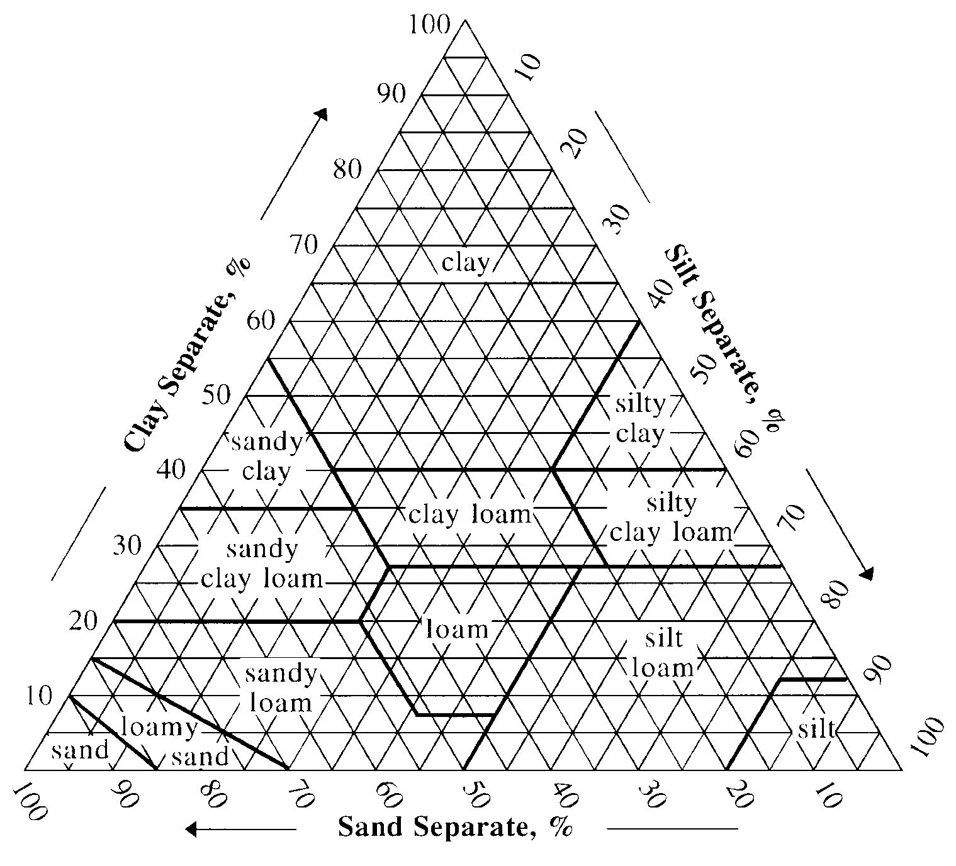

Attachment 2 – Interpretations Tables

Criteria for Evaluating Soil Limitations for Septic Tank Effluent Treatment Areas (modified from Missouri Onsite Wastewater code regulated by the Missouri Department of Health and Senior Services)

Criteria | Suitability
 | Suitable | Provisionally Suitable | Unsuitable
Average hydraulic conductivity  (45-180 cm depth) | MH, ML | ------ | VH, H, L, VL
Depth to wetness (cm) | 105+ | 75-105 | < 75
Coarse fragments  (45-105 cm depth) | < 15% | 15-50% | > 50%
Depth to bedrock  (Cr or R) | > 165 cm | 105-165 cm | < 105 cm
Slope | < 15% | 15-30% | > 30%
Flooding/ponding | none | ------ | any

Criteria for Evaluating Soil Limitations for Dwellings without Basements.

Criteria | Limitations
 | Slight | Moderate | Severe
Texture of most limiting horizon  (25-100 cm depth) | S, LS, SL, L,  SIL | CL, SICL,  SCL | SIC, SC, C
Average rocks >7.5 cm diameter  (0-100 cm depth) | < 25% | 25-50% | > 50%
Wetness class | 1, 2 | 3 | 4, 5
Depth to hard bedrock (R) | > 100 cm | 50-100 cm | < 50 cm
Depth to soft bedrock (Cr) | > 50 cm | < 50 cm | -------
Slope | < 9% | 9-15% | > 15%
Flooding/ponding | none | none | any

Attachment 3 – Example

NACTA SOILS CONTEST 2-Year Division
SITE CARD

SITE NO.

Describe _ horizons to a depth of cm

Marker is at the lower boundary of the third horizon at cm

