Certificate in Crime Mapping & Analysis (12 hours)
The certificate in crime mapping analysis is designed to familiarize the criminal justice practitioner or future practitioner with crime analysis and geographic information systems, to better understand crime mapping and the impact that it has for keeping communities safe. The certificate combines practical and theoretical bases of knowledge towards this end. Students are ideally pursuing a major or minor in either Criminal Justice and/or Geosciences.
Courses required to earn the Certificate in Crime Mapping & Analysis include:
CRJ 355 | Criminal Investigation | 3 Credit Hours
CRJ 395 | Crime Analysis | 3 Credit Hours
GSCI 240 | Intro to Geographic Information Systems | 3 Credit Hours
GSCI 360 | Intermediate Geographic Information Systems | 3 Credit Hours
No grade lower than a “C” is acceptable for the classes taken to complete the certificate.
To obtain an official certificate for the Certificate in Crime Mapping & Analysis, fill out the Intent to Complete a Certificate in Crime Mapping & Analysis form on the right side of this page, and return to the Department of Criminal Justice. If you have met all the requirements, you should receive your certificate in the mail, approximately 3 – 4 weeks from the date of approval.
The Department of Geosciences can be contacted at (785)628-4644 or by email at geosciences@fhsu.edu.

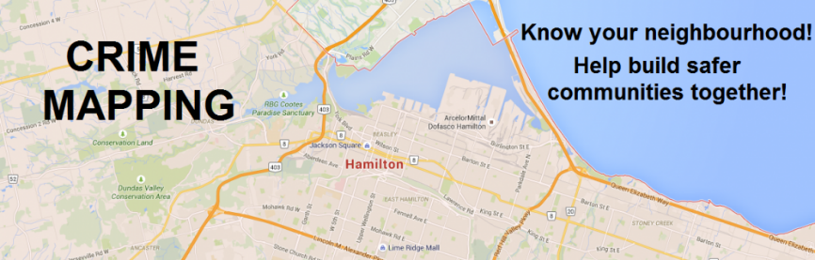
FORT HAYS STATE UNIVERSITY
DEPARTMENT OF CRIMINAL JUSTICE
Intent to Complete a Certificate in Crime Mapping & Analysis
Student ______________________________________________________ (Last Name) (First Name) (Middle Name)
Student ID# ___________________ Phone Number _______________
Major ________________________ E-mail _______________________
List the address the certificate should be mailed to:

(Street Address) (Apt. #)

(City) (State) (Zip Code)

Please indicate semester, year, and grade for each class completed:
Semester | Year | Grade
________ | _____ | _____ | CRJ 355 Criminal Investigation
________ | _____ | _____ | CRJ 395 Crime Analysis
________ | _____ | _____ | GSCI 240 Intro to Geographic Information Systems
________ | _____ | _____ | GSCI 360 Intermediate GIS Systems
Student Signature ______________________________________________

For office use:
Certificate request approved on ________________________________________
Certificate printed on ________________________________________________
Certificate mailed to student on ________________________________________
131 Rarick Hall · 600 Park Street · Hays, KS 67601 · (785)628-5668
Criminal Justice · www.fhsu.edu/criminaljustice/
Geosciences · www.fhsu.edu/geo/

