2020 Fair Labor Standards Act (FLSA) Changes
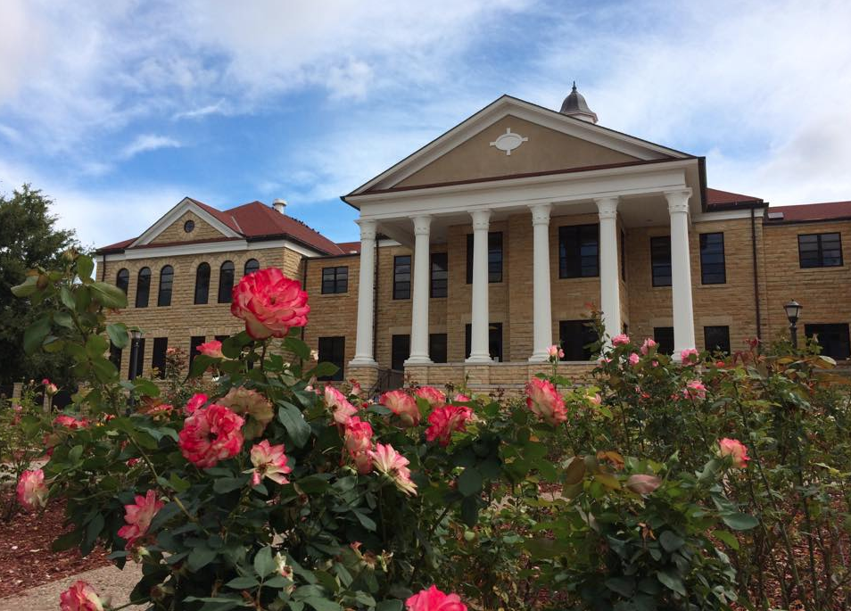
Toolkit for Managers and Staff

2020 Fair Labor Standards Act (FLSA) Changes
Toolkit for Managers and Staff

About This Toolkit

More university staff will be eligible for overtime pay under changes to the Fair Labor Standards Act (FLSA) that take effect on January 1, 2020. If you are impacted by these changes, this toolkit is designed to help you:
- Understand what you can expect as a result of a change in FLSA status
- Prepare for changes in time reporting

If you have additional questions after reading these materials, please contact your supervisor or human resources representative.

Table of Contents

A Brief Guide to the Fair Labor Standards Act
- Employee Guide to Becoming Eligible for Overtime
- Frequently Asked Questions

A Brief Guide to the Fair Labor Standards Act

The Fair Labor Standards Act (FLSA) determines whether a position is eligible for overtime pay. An “exempt” position is not eligible for overtime pay. A “non-exempt” position is eligible and must receive overtime pay at time-and-one-half for any hours worked above 40 hours in one workweek.

Three Tests: Salary Basis, Duties and Salary Level

A position may be considered exempt under the FLSA if it meets three tests.

  - Employee must be paid on a salary basis, not an hourly basis
  - Duties must meet criteria for executive, professional, administrative or specific computer activities
  - Compensation rate must be at least $35,568 annually (effective January 1, 2020)

If any one of the three tests is not met, the employee must be classified as non-exempt and eligible for overtime pay. Please note that exempt classification is an option, not a requirement under the law. A position that meets all three tests may still be classified as non-exempt.

FLSA status affects the following areas of employment:

- Eligibility for overtime pay for hours worked above 40 in one workweek
- How time is reported

This will not change your base annual wages assuming you are in pay status through (regular hours worked, holiday time, annual leave, sick leave, etc.) pay period. Your UPS or USS employee type will not change, and your health and other benefits will remain exactly the same.

What Counts Towards Overtime?

Only time worked is counted toward the 40 hours per week required for overtime pay for non-exempt employees. Approved time off such as vacation, sick, discretionary day, funeral, inclement weather and time for jury duty does not count toward the 40 hours per week of time worked that is required for overtime pay.

To Learn More

For more information, visit http://www.fhsu.edu/humanresourceoffice/Fair-Labor-Standards-Act/ or the U.S. Department of Labor’s Wage and Hour Division at dol.gov/whd/flsa.

Employee Guide to Becoming Eligible for Overtime

In order to comply with revised Fair Labor Standards Act (FLSA) regulations announced by the federal government in September 2019, your position will be considered eligible for overtime pay (or “non-exempt” under the FLSA) as of December 29, 2019. This overview provides a summary of how this change will impact you, a timeline of key dates and a guide to common considerations.

How This Change Will Affect You

Overtime
You will become eligible for overtime pay effective December 29, 2019. As of December 29, you must record all hours worked, including overtime hours, and you will receive additional pay for overtime at one-and-one-half times your regular rate of pay for all hours worked above 40 in one workweek. If your supervisor has not specifically requested that you work overtime, you will need to obtain approval before doing so.

Rate of Vacation or Sick Leave Accrual
Your current rate of monthly vacation or sick leave accrual will not change as a result of your new overtime eligibility. You will continue to accrue vacation or sick leave time at the same rate in effect.

Time Reporting
You will begin reporting your time worked in addition to time off as of December 29, 2019. All time work and time off is reported in quarter hour increments.

Comparing Exempt and Non-Exempt FLSA Status

 | NON-EXEMPT | EXEMPT
Overtime pay | Time-and-one-half for all hours worked above 40 in one workweek | Not eligible
Reporting work time | Report all hours worked in quarter hour increments | Do not report hours worked
Reporting exception time | Report time off in quarter hour increments | Report exception time
If employee  works on a holiday | Paid time-and-one-half | Paid straight time

What Will Not Change

Your current rate of pay, benefits, job family, job title and rate of vacation or sick leave accrual are not affected by this change.

Key Transition Dates

Dec 29, 2019 | Start of first biweekly pay period; begin recording time worked and time off
Jan 11, 2020 | End of first biweekly pay period
Jan 13, 2020 | First time sheet due to manager

What You Need to Do

You will need to work with your manager, timekeeper, accounts payable (Payroll unit) or human resources representative to make sure that you know how to report time correctly starting December 29, 2019. You should also discuss with your supervisor how this change may impact scheduling of regular and overtime hours.

To Learn More

Contact your supervisor or department human resources representative with any questions, or
visit fhsu.edu/humanresourceoffice/2019-flsa-changes.

Frequently Asked Questions about FLSA changes

Note: FAQs will be monitored and updated periodically.

Once I start reporting time worked by the quarter hour, will I still get paid if I don’t submit my timesheet on time?
You must report hours worked and time off for each biweekly pay period before the pay period cutoff. If an unusual event occurs and you are unable to submit your time report before the deadline, you need to communicate immediately with the Payroll unit.

Therefore, you need to submit biweekly time reports prior to the cutoffs to avoid a delay in pay for all hours worked within the pay period and to ensure your leave balances are up-to-date.

Can non-exempt employees have flexibility in their work hours?
Yes. Special or alternate scheduling is allowed within the same workweek. For example, if you normally work 8 hours a day, and have a personal appointment on Monday that only allows you to work 6 hours, you and your supervisor can agree that you will make up the time later in the same workweek. Another example would be if your typical schedule is 8 hours a day during the day, and your department needs you to work a special event for 4 hours during the evening. Your schedule may be changed to give you 4 hours of time off at another time during the same workweek. Note: Special or alternate schedules must be within a single workweek. The workweek is defined as beginning Sunday through Saturday at midnight.

Will I be paid overtime if my supervisor did not approve it?
Yes. If non-exempt employees perform work, they must be paid for it. However, supervisors have discretion to establish overtime approval processes. If an employee continues to work overtime without supervisor approval, then the supervisor could begin taking possible disciplinary action with the employee.

Will my pay change?
No, an employee’s rate of pay will not be affected by this change.

Can a supervisor require overtime?
Yes, overtime can be required. Supervisors are encouraged to give as much notice as possible to staff members.

Does time spent answering emails or using a mobile phone for work outside of normal hours count towards overtime?
For non-exempt employees who respond to emails or calls outside of the normal hours or while on lunch breaks on a “regular” basis, that time is counted as work time for overtime purposes. If a non-exempt person responds to emails or calls “very occasionally,” then court cases have considered that to be “de-minimis” and therefore not counted for overtime purposes. However, supervisors have discretion to establish overtime approval processes. If an employee continues to work overtime without supervisor approval, then the supervisor could begin taking possible disciplinary action with the employee.

What if I work on my lunch break?
Departmental lunch breaks are at least 30 minutes and are scheduled by the department. During this time, a staff member cannot be required to continue to perform job duties unless he or she is paid for the work time.

Can I waive overtime as a non-exempt employee?
No, employees don’t have the option of waiving the legal requirements.

Will my benefits be affected?
No, employees current benefit package will not be affected by this change.

Can non-exempt employees also hold exempt positions on campus?
No, employees can’t hold two different positions with different FLSA status.

How will Overtime be managed?
Managers and supervisors may need to set expectations and change department schedules or behaviors in order to manage overtime. Overtime may occasionally be necessary and should be pre-approved by the supervisor; however, whether pre-approved or not, it must always be paid. A defined approval process can assist both managers and employees in managing time.

How do I handle my mobile devices?
Mobile devices have expanded the opportunity for work to be performed outside of normal work hours. Employees who were previously classified as exempt may be used to responding to emails or calls after hours, but these activities must be counted as paid work time (and potentially overtime) for non-exempt employees. Departments may need to set a new expectation with employees about answering emails or calls outside of normal hours.

Can I request or require that a non-exempt employee work over 40 hours in a week and offer “comp time” (unpaid time off taken in a later workweek) instead of pay for overtime?
No. FHSU does not recognize “comp time”. Other forms of payment, such as compensatory time off, are not to be used.

