
How to Apply for a Research Grant within Workday

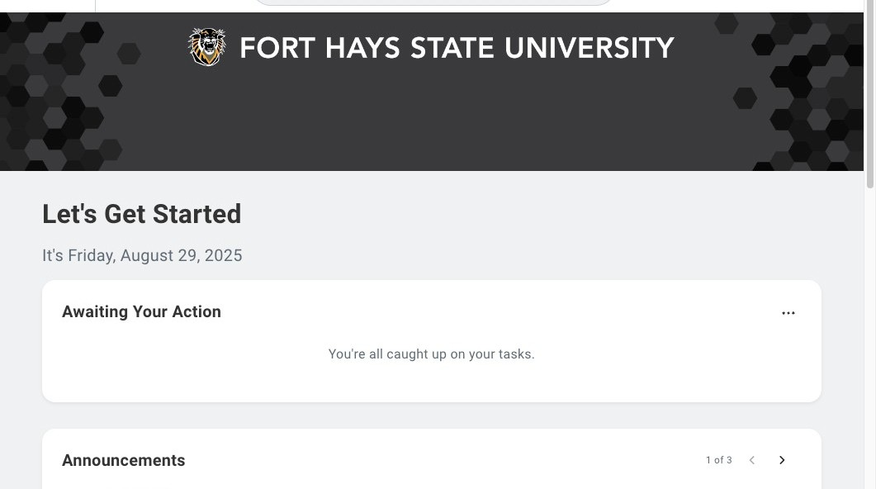

1 Navigate to https://www.myworkday.com/fhsu/d/home.htmld

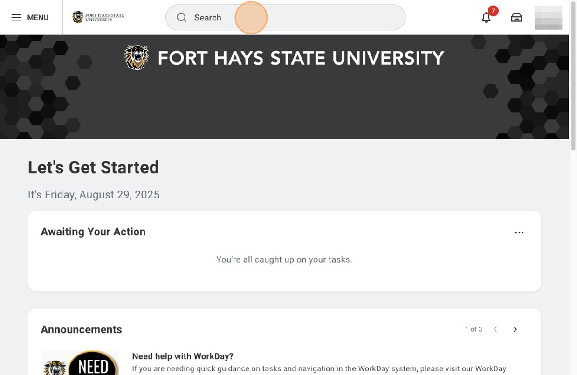

2 Click the "Search" field.
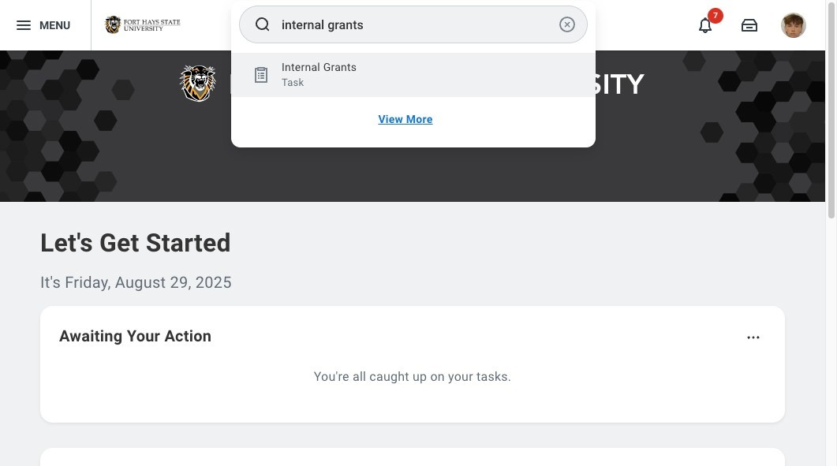

3 Type "internal grants"

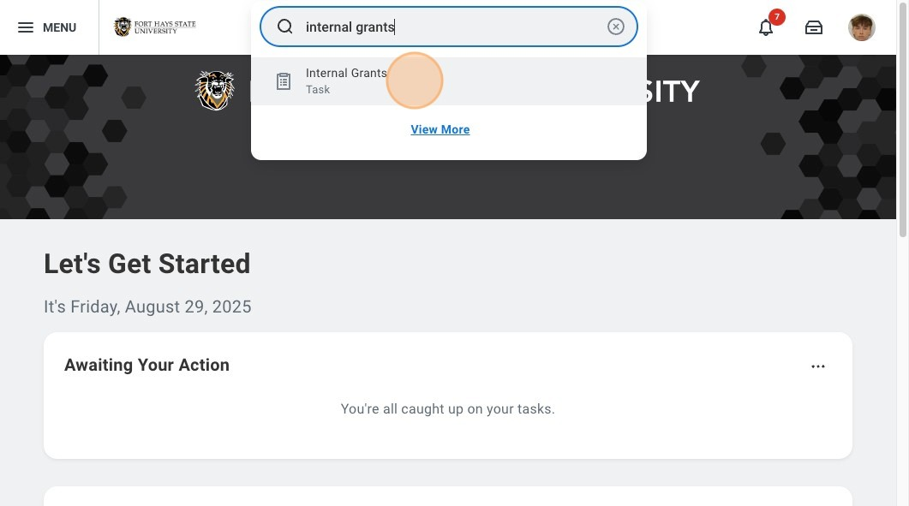

4 Click "Internal Grants"

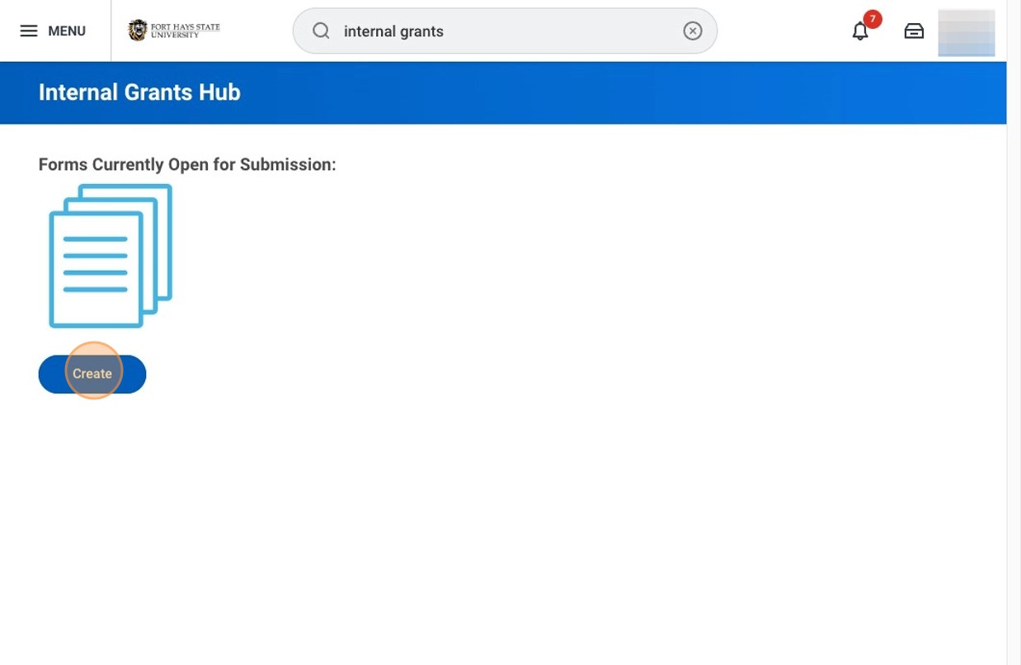

5 Click "Create"
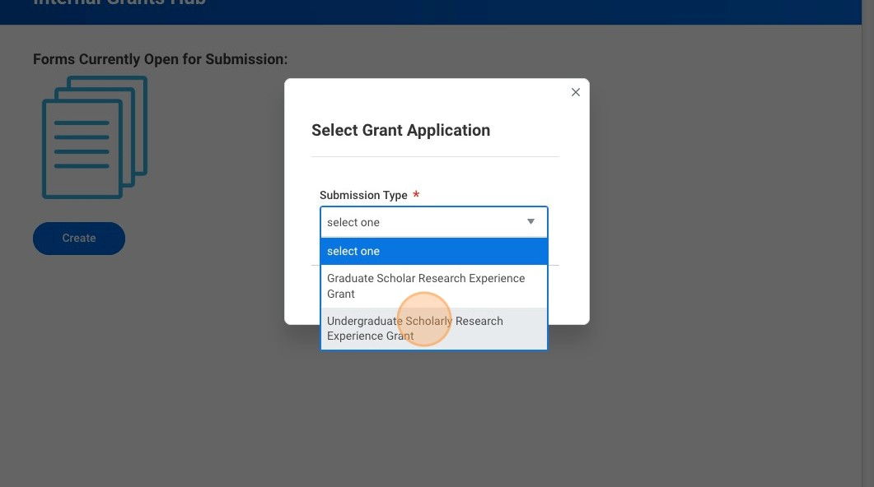

6 Select the grant you would like to apply for from the dropdown.

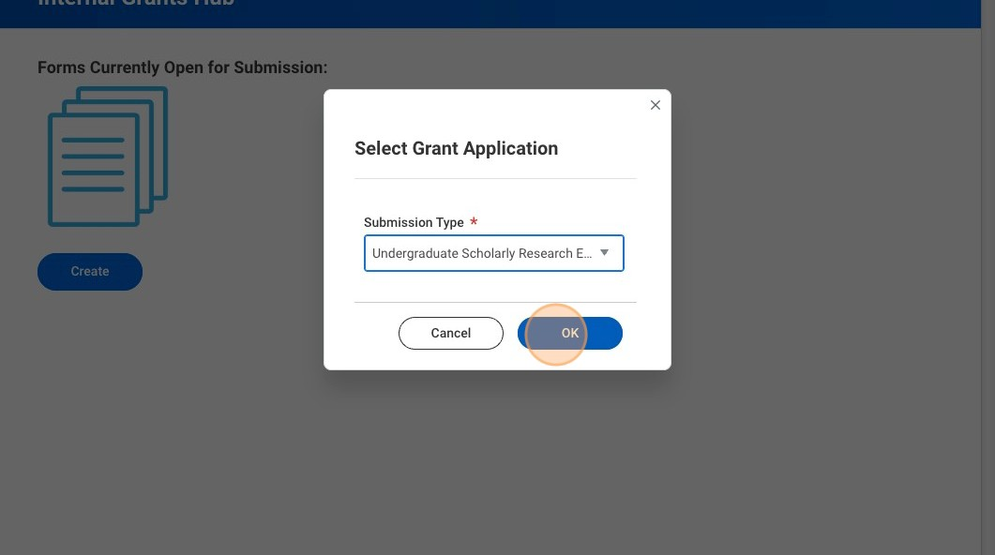

7 Click "OK"

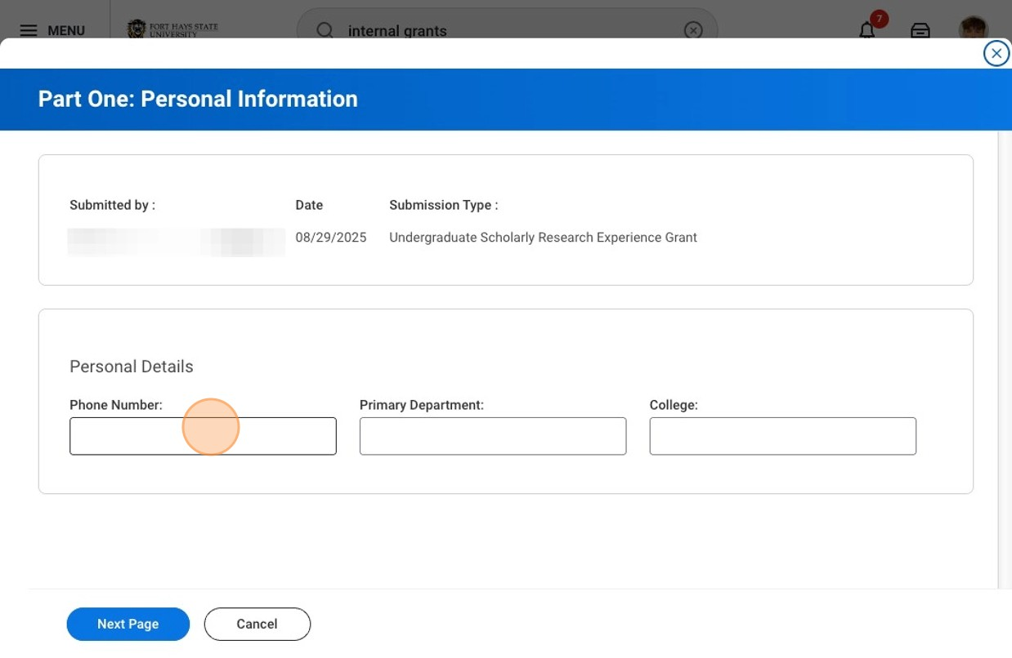
8
Fill in your information. Your primary department is your major, and college is the unit your major falls within (Ex. Werth College of Sciences, Technology and Mathematics).

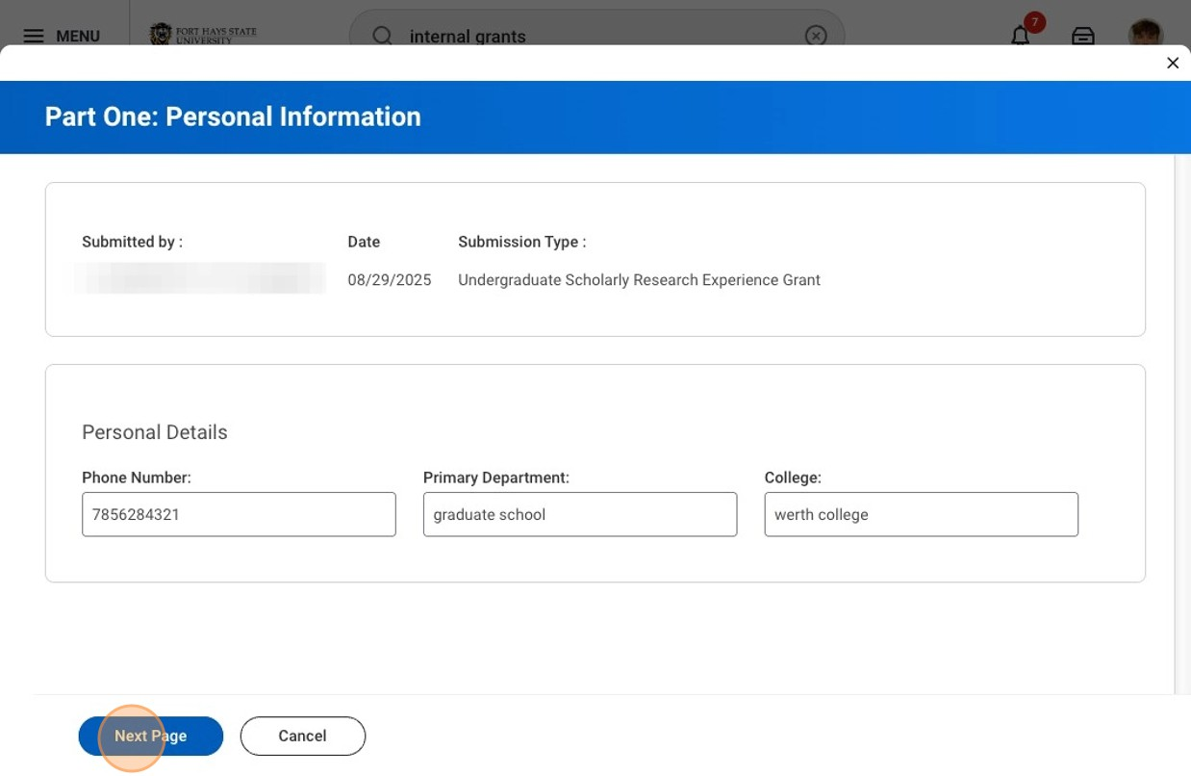

9 Click "Next Page"
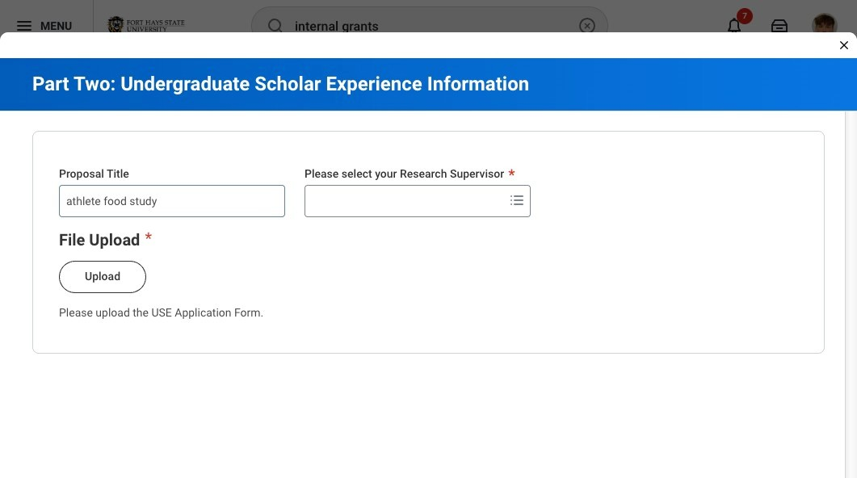

10 Enter the name of your project/proposal.

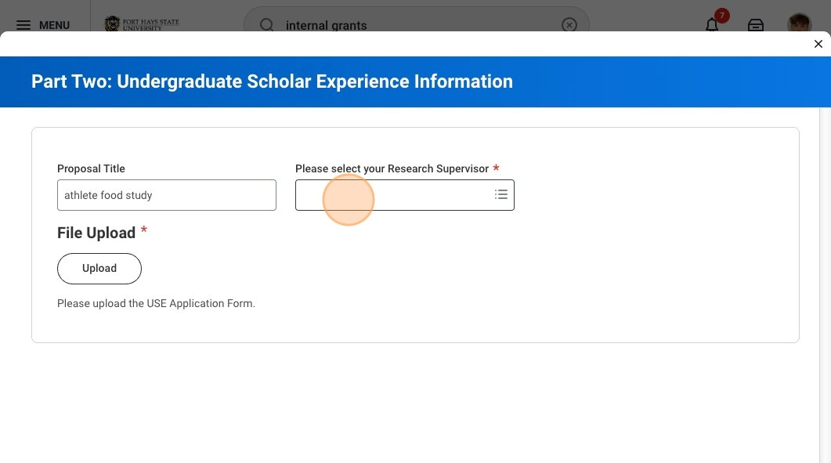
11
Click the "Please select your Research Supervisor" field, and type the name of your research advisor. Workday will auto populate the name and you will need to select the correct person.
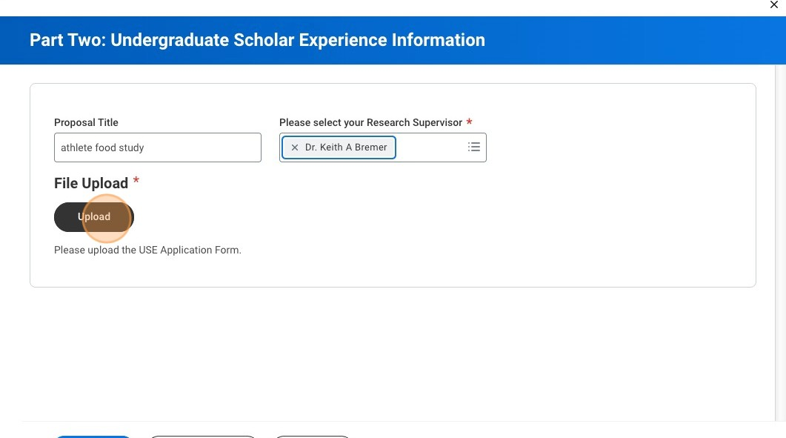
12
Click "Upload" and select all the files that need to be attached for your application. Please see informational email for required documents needed for your application.

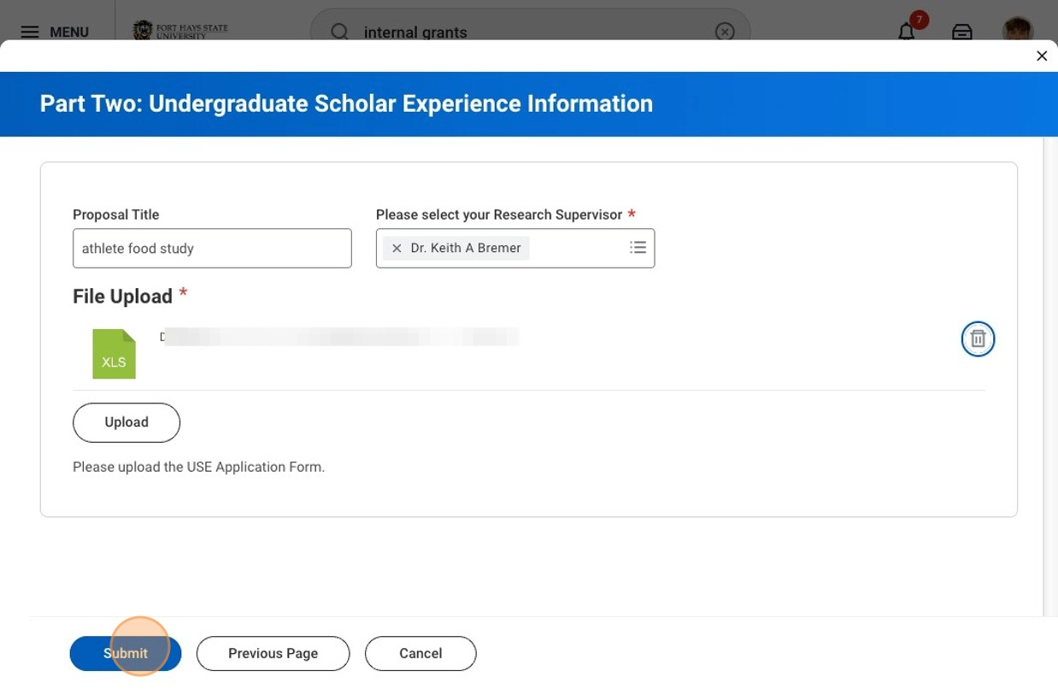

13 Click "Submit"



14 Click "Submit". You must click submit again to fully submit your application.

