Western Kansas Lego Robotics Competition

April 4 2022

Fort Hays State University

FHSU is hosting our 16th annual Lego robotics competition. The competition is open to all area middle school students (grades 5-8).
This event will be held at the campus of Fort Hays State University on Monday, April 4, 2022. The event will start at 10:00 a.m. (registration begins at 9:00 a.m.) in the Ballroom of the Memorial Union. The event will end by 3:00 p.m. Any changes to this plan due to Covid health recommendations/requirements will be announced here as they are known.

For 2022 we have created four all new challenges for the students competing, and the always popular sumo bot tournament returns once again.

To allow the greatest possible number of schools to compete, these competitions have been designed so that they can be completed equally well using NXT, EVO, or the new Mindstorms 51515 kit.
Each team of students will compete in at least one event and up to as many as they wish (there will be a total of 5 events). A team may consist of 1-5 members. Multiple teams from one school are permitted.
Each competing robot must be constructed solely from parts found in one or more standard Lego Mindstorms robot kits, including: the new Mindstorms robot inventor kit 51515, NXT, or NXT 2.0 kits, or EV3 kits. All events require that the robots be autonomous. Operating a robot during competition via any form of wireless or remote control is forbidden. Teams with robots found to be in violation of the rules will be disqualified. If competition courses are set up outside of the main event areas, teams may use them for practicing. However, teams may not practice on courses set up in the competition area unless given permission by the judges. Remember, due to time constraints this is purely a competition event. Students are expected to have fully working programs upon arrival.

It is expected that all robots will be programmed to begin competing at the press of a button on the hub. Calibrations of sensors (e.g. black/white light/color sensor intensity calibrations) will be allowed (and is encouraged). The contest will begin upon the final pressing of the starting button (a delay between pressing the button and robot motion will be required in some competitions as detailed below). Teams will get only two chances to successfully start their robot. This means that if the wrong program is started by accident the team can tell the judges and have one more chance to start their robot. Teams must use their “second chance” immediately; no additional programming can be done once the team has been called to compete. It is not required for the robot to automatically stop at the completion of an event unless otherwise specified; when the judges have finished they will indicate that the robot can be picked up and deactivated.

Awards will be given for 1st, 2nd, & 3rd places in each event, as well as an overall traveling trophy for the team that acquires the largest number of total points (first place team award). Second and third place team awards will also be given. Points will be awarded for the top-five ranked teams in each event: 1 pt for 5th place, 2 pts for 4th place, 3 pts for 3rd place, 4 points for 2nd place, and 5 pts for 1st place. Exception: only the top 4 teams will be awarded points in the Sumo Bot event. No points will be awarded to teams who place below the top five in each event. The school with the most points (total earned by all its teams) will be awarded a plaque.
The event’s final arbiter will decide on any events that arise which are not detailed here.

1: Roadblock challenge:

Students must program their robot to autonomously navigate from the green start box to the red ending box. There are 4 paths but three of them will be blocked by roadblocks that the robot cannot touch or cross. The robot must find and navigate the open path to the red end zone. The fastest time wins- but watch out- the run is disqualified if the robot touches a roadblock.

The competition will be as follows:

The robot must fit completely within a 10-inch diameter circle. The robot must operate autonomously, no commands or controls by students allowed after the start.
The student will place the robot on the green starting square, the robot must be completely inside the start area.
Upon pressing the start button the robot must pause for 15 seconds before it starts to move.

During that 15 second time the judge will move the yellow roadblocks in the course to a position that blocks 3 of the 4 paths and leaves one open.

The robot must now navigate the maze.

If the robot touches a roadblock the run will be disqualified.

Time will stop when the robot is completely inside the red end zone.

Each bot gets 2 chances to navigate the maze- the fastest run will be recorded as their time.

If the bot gets stuck or has not completed the run within 5 minutes, the judge will end the run.

See diagram of the course below:

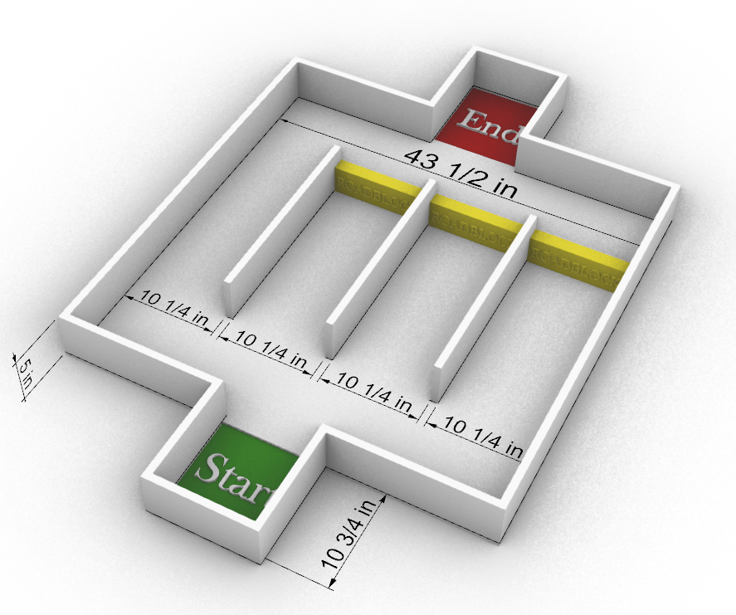

2: Mountain climber challenge:

Students must create a bot that can climb up one side and down the other of a steep smooth ramp. The slope of the ramps will be 45 degrees on both the up and down side. The ramp is 2 feet wide and 4 ft tall at the highest point. The robot must be no larger than a 12” x 12” x12” cube.

The climbing ramps of the mountain will be constructed of smooth white painted plywood

If the bot falls over or falls off the mountain ramp the run is disqualified

If the bot gets stuck or has not completed the run within 5 minutes, the judge will end the run.

The competition will be as follows:

Student will place the robot in the green start square at the bottom of the mountain ramp
The student will press the start button. Then the robot will climb up the mountain and down the far side, stopping in the red end zone. The run will end when the robot comes to a complete stop. The winner will be the robot that completes the course in the fastest time.

See course diagram below:

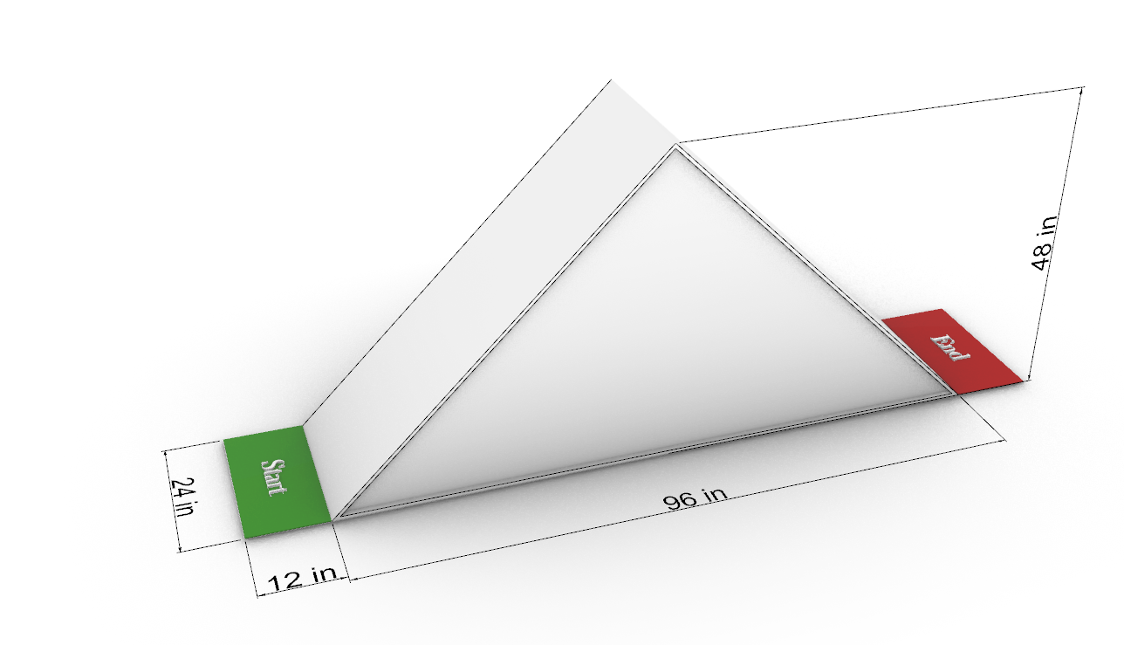

3: Time Trial retriever challenge

Students will build a robot that can follow a curving 1-inch wide black line across a white playing field, grab a red 16 oz plastic (solo style) cup positioned at the end of the line and carry it back to the green 12”x12” starting square in as close to exactly 1 minute as possible. Winner is the bot that delivers the cup back to the starting square in the time closest to 1 minute. Deviations above or below the target time are weighted equally: (example, a run that takes 50 seconds and a run that takes 70 seconds would be considered a tie as they are both a 10 second deviation) The path will be 4 feet long (for a total travel distance of 8 feet). The path will be continuous with no 90-degree corners and will not cross itself or branch. Students will not know the layout of the line beforehand day of event. Bot can be no larger than a 12”x12” 12” cube

If the bot gets stuck, goes off the playing field, or has not completed the run within 5 minutes, the judge will end the run.

If the bot follows the line and returns to the starting box but does not pick up the cup or drops the cup before it reaches the starting box 30 penalty seconds will be added to it’s run time.

The competition will be as follows:

The student will place the bot in the starting box and press start button.
The bot will travel the line, pick up the red plastic cup and return to the starting box.
Both bot and cup need to be completely within the 12”x12” starting box
Time ends when the bot has come to a complete stop.

4) Minesweeper
Within a 43.5 in x43.5-inch square playing field, bordered by a 5-inch-tall wall the robot must find the mine and stop in place on top of it to mark it. The bot will alert the judge for 5 seconds when it does, either flashing lights, displaying a symbol on the screen or playing an audible sound. The winning bot is the one that finds the mine and marks it quickest. Time ends when the bot comes to a complete stop. The playing field and the border walls will be painted white. Bot can be no larger than a 12”x12” 12” cube
The mine will be a 3-inch diameter red circle of paper.
The mine will be placed at an unknown location on the playing field.

If the bot gets stuck or has not completed the run within 5 minutes, the judge will end the run.

The competition will be as follows:

The student will place the bot over the small black x in the center of the playing field and press start button.

The bot will pause for 15 seconds with no motion. During that 15 seconds the judge will place the mine at some location within the playing field.

After the 15 second pause the robot will begin moving around the playing field to find the mine.

When the robot finds the mine and comes to a stop, the mine must be at least partly covered/ by the robot. The robot’s alert must be obvious to the judge.

The winner will be the bot that finds the mine quickest and alerts the judge.

See diagram of course below: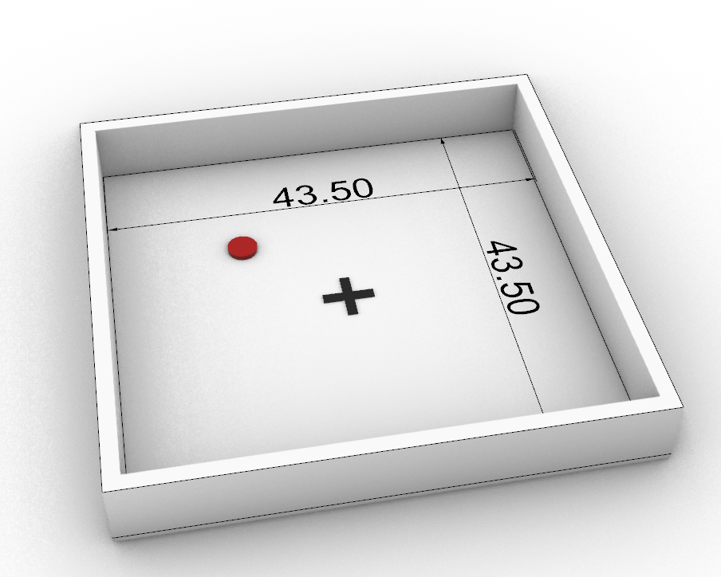

5) Sumo Bots Tournament
Robots will advance though a bracket of matches, in each match two robots will face off in an elimination style Sumo competition. The winning robot advances up the bracket until a champion is found. The robots must be fully autonomous with no remote control. The playing field is a 4-foot diameter white painted wood regular octagon. The edge of the playing field is marked with a 4” wide black strip, or “danger zone”. The robot playing surface will be slightly elevated above the floor. There is no size restriction for robots but robots with a weight greater than 2 lbs will be disqualified; the robots will be weighed before competing. The first robot to fall off the playing surface and touch the floor loses.
Competition will be as follows:
Students will place the robots in the center of the playing field. 14 inches apart in a back-to-back position.
Students will press the start button and the robot will pause for 5 seconds before moving.
After 5 seconds have elapsed the robots first motion must be to rotate 180 degrees.
The robots will now attempt to push each other off the playing field. A robot is considered off the playing field when any part of it touches the floor, including a piece that has detached or fallen off.
If after 90 seconds both robots are still on the playing field the robot that weighs less will be considered the winner and will advance in the bracket.
Point scores for the top four teams will be given; (the losers of the semifinal round will face off to get 3rd and 4th place, while the final round will determine 1st and 2nd place). First place gets 5 points, 2nd place gets 4 points, etc.
See playing field diagram below:
